OFFICE OF THE SHERIFF

Sheriff Curtis L. Landers
225 W. Olive Street
Newport, Oregon 97365
(541) 265-4277
Fax (541) 265-4926

MEDIA RELEASE
FOR IMMEDIATE RELEASE

Date: February 21, 2020

Contact: Virginia “Jenny” Demaris, Emergency Manager
(541) 265-4199
vdemaris@co.lincoln.or.us

LINCOLN COUNTY EMERGENCY PUBLIC INFORMATION CALL CENTER

(02.21.20 - Lincoln County)

Lincoln County Sheriff’s Office and Public Health Department are releasing their new short video and information guide on the Lincoln County Emergency Public Information Call Center.
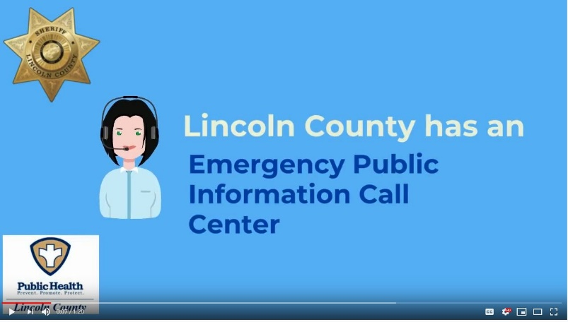
The video provides an interactive overview of when and how the call center can be utilized by those impacted by community disasters or emergency events. The information guide can be printed for work or home as a reminder of how and when to contact the call center.

Helpful tips related to the call center are:

- Save the Call Center phone number and County Emergency Management website in your contacts under Lincoln County Emergency Public Information Call Center at 541-265-0621, https://www.co.lincoln.or.us/emergencymanagement so you have them when you need them.
- Watch the short video in advance so you know what to expect when you contact the call center - https://youtu.be/ugtRjjWt06U
- Save the American Red Cross “Safe and Well” website in your contacts to assist with reuniting with family members when separated during disasters - https://safeandwell.communityos.org/cms/index.php.

Lincoln County Sheriff, Curtis Landers, and Public Health Director, Rebecca Austen, extend their sincere appreciation to our local community volunteers, over 120 trained, to be able to respond and staff the call center when needed.
- Lincoln County Sheriff’s Office Auxiliary Communications Service
- Lincoln County Emergency Management Volunteers
- Community Emergency Response Team Chapters of Lincoln County – Depoe Bay Fire District, Newport Fire Department, North Lincoln Fire and Rescue (North County), Central Oregon Coast Fire and Rescue (South County communities).

Fore more information go to the County Emergency Management Call Center Webpage at https://www.co.lincoln.or.us/emergencymanagement/page/lincoln-county-emergency-public-information-call-center

###
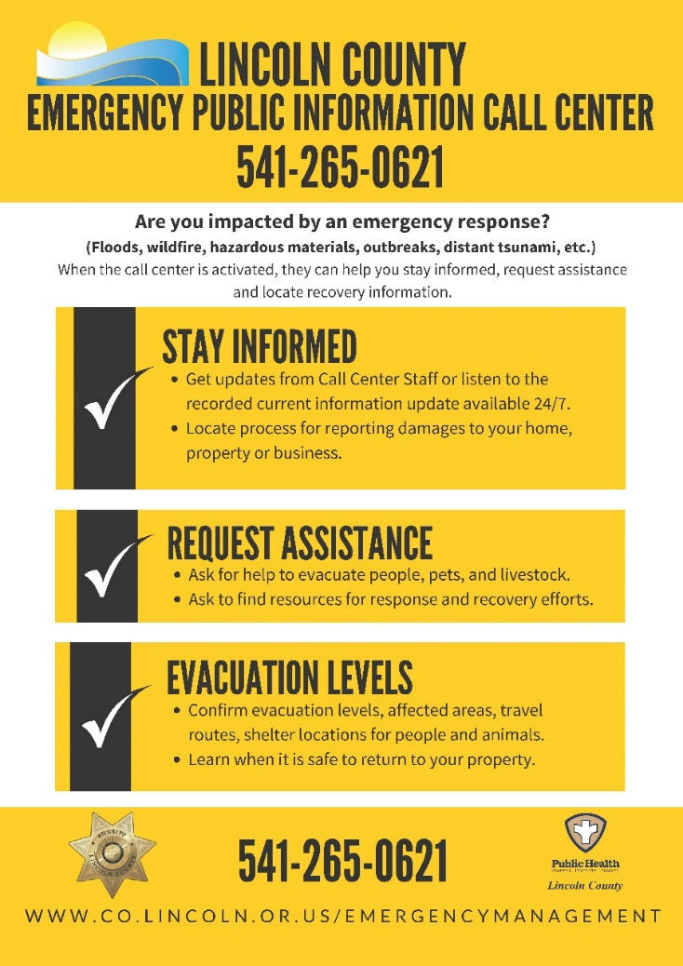
Respectfully submitted,

Virginia "Jenny" Demaris
Emergency Manager
Lincoln County Sheriff's Office
Emergency Management
225 W. Olive St.
Newport, Oregon 97365
vdemaris@co.lincoln.or.us
(541) 265-4199 Office

