Benton-Franklin Workforce Development Council
Annual Report

CEO, Tiffany Scott
To All Who Call Benton and Franklin Counties Home,

Although we have been incorporated as a 501c3 since 1984, to my knowledge, this is our first annual report to the community. I will start by using the same cadence as many Chief Executive Officers (CEO) and then end the only way I know how with reflection and from the heart.

Program Year (PY) 2019 (July 1, 2019, to June 30, 2020) was the most dynamic in my career as a Workforce Development Professional.

The Benton-Franklin Workforce Development Council (BFWDC), along with its partner, the
Educational Services District (ESD) 123, opened a comprehensive re-engagement center for Youth and Young Adults called TC Futures. It was exciting to see an almost 2-year collaborative effort come to fruition in August 2019. We are fortunate at this center to be able to offer employment and training services to customers in an environment that encompasses their generational preferences.

The Tri-Cities is growing quickly with estimates of 300,000 populous. It is important that as the convener of our local Workforce Development System that we focus on the rural communities in Benton and Franklin Counties. Following a competitive process, the BFWDC was awarded resources to serve job seekers in North Franklin County from a grant called Economic Security for All (EcSA). These resources are helping individuals get out of poverty and become self- sufficient.

The BFWDC is governed by the Workforce Innovation and Opportunity Act (WIOA) compliant board of directors comprised of 21 talented, intelligent volunteers from our local area representing labor, business, government, and education. After great input, discussion, and consensus from the BFWDC Board and Board Staff, we changed our mission and vision statements in December 2019. Now, the words resonate more with the scope we perform as leaders in our field. Also, through a two-day Board Retreat, the BFWDC codified four strategic goals addressing outreach, service delivery, funding diversification, and partnership development. We began the work in PY19 and will continue in PY20.

Just a few months into 2020, we began hearing words regularly that were not familiar in our society. Coronavirus, Pandemic, COVID-19, Social Distancing, and Personal Protective Equipment, to name a few. I think we can all agree that our current state is unlike any other we have experienced in our lifetimes. The BFWDC is committed to contributing to solutions related to this crisis by addressing the crippling effects of widespread unemployment by obtaining resources that support getting people back to work. To date, we have secured a little over an additional million dollars in Disaster Recovery National Dislocated Worker Funding and Employment Recovery National Dislocated Worker Funding from the Department of Labor through a competitive grant process. This by no means is enough; however, it is a start, and we will continue to find opportunities to help. For those seeking services, please reach out to our American Job Center, WorkSource Columbia Basin, at 509-734-5900 or TC Futures, at 509-537- 1710. During business hours, leave a message after selecting the general inquires prompt then a local, live person will return your call within the hour. This is because our local Workforce System is currently operating virtually due to COVID-19.

The BFWDC and the Workforce System we oversee was recently recognized for our excellence in the area of Equal Opportunity and received the national William J. Harris award. Although we are proud of this achievement, we
know there is always more that can be done when it comes to inclusion and accessibility for all. I would be remiss if I did not mention the racial injustice and inequality happening throughout our Nation. Engaging in honest dialogue, while needed, will not solely create system change. More people of color and LBGTQ must have a seat at the decision-making tables in our community. When BFWDC board seats become vacant, I commit to more diverse representation, and I challenge my peers in Benton and Franklin Counties to do the same. This is one step forward with many more to follow.

In closing, I would like to share words I carry with me always that come from two women I respect immensely. The first, my mother, who the day after losing her son, my brother, in a car accident, reminded me that the sun will come up tomorrow. An optimist even in a time of grief. I have used her perspective and strength to focus on what is next during challenging times and affirm that the future will be better than today. The second, my grandmother, who was raised in the smallest of towns in Iowa and who lived through the great depression, would say, it takes all kinds of people to make the world go around. She knew that life would not be as meaningful if we were all the same.
Although she has passed, the love she embraced her fellow humankind with still lives in her children, grandchildren, and great-grandchildren.

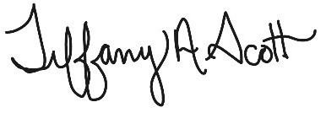Until next year, be kind, stay healthy, and know we will get through this together. My Best,

Tiffany Scott, CEO

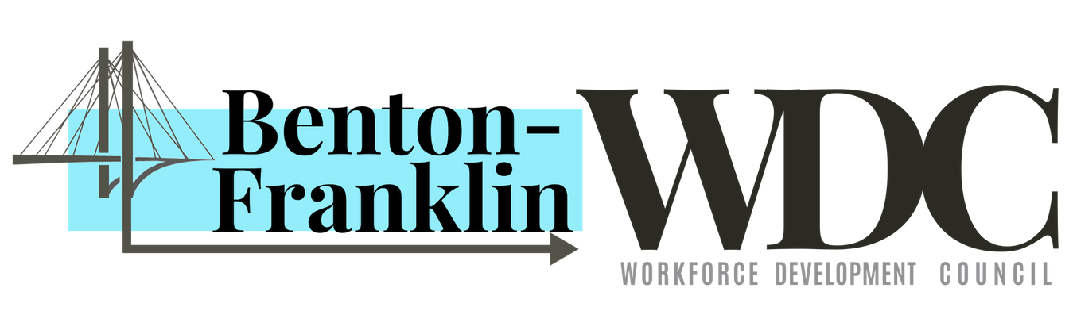

815 N. Kellogg Street, Suite C, Kennewick, WA 99336 509-734-5980
https://www.bentonfranklinwdc.com/

Thank You
We would like to express our thanks to our funders

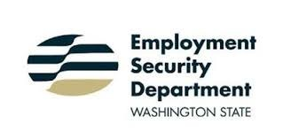

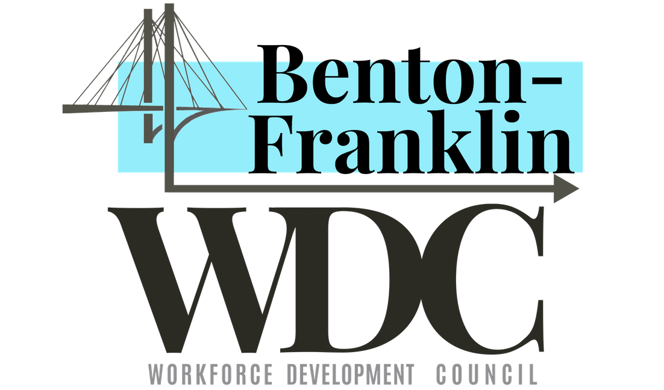
Vision:
Benton-Franklin Workforce Development Council (BFWDC) contributes to our prosperous community by elevating the human potential.
Mission:
Promoting a prosperous community by providing a progressive workforce system.

What is the Benton-Franklin Workforce Development Council (BFWDC)?
The Governor has designated Benton and Franklin Counties as a local workforce area, based on population, size, prior education, training performance, and fiscal integrity. The BFWDC is responsible for coordinating the local workforce development programs, coordinating activities of the local employment and training One-Stop center and TC Futures, establishing a youth committee, negotiating local performance standards, and developing a local Workforce Innovation and Opportunity Act (WIOA) plan.
The council sets policy and presides over the direct expenditures of over $4 million in workforce funds to assist
individuals interested in furthering their education, upgrading skills, job placement, etc., in addition to providing services to employers. The BFWDC is also responsible for the oversight and monitoring of the One-Stop delivery system.

Programs overseen by the BFWDC in Program Year 2019
July 1, 2019 - June 30, 2020

WIOA Title I Programs - Adult, Dislocated Worker (DW), Out of School Youth (OSY) and Rapid Response Increase Employment (RRIE) Career Connect Washington (CCW)
Families Forward Washington (FFW) Economic Security for All (EcSA)

Business Engagement

Jobs

7,235 582 7

Jobs Posted to WorkSourceWA.com

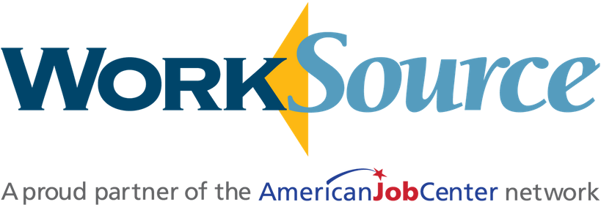

Job Seekers
Businesses with Jobs Posted to
WorkSourceWA.com

6,326
Job seekers helped by the Benton-Franklin WorkSource System
There were 23,639 Staff Assisted Services

228
Job seekers obtained employment with the help of Adult, DW and RRIE
Rapid Response Events Provided to Employers

554
Job Seekers were served in the Adult, DW, RRIE FFW and EcSA programs

Board Members

51% of the Board is comprised of members of local businesses. Also represented are Economic
Development, Education, Labor and State Agencies

Adolfo de Leon DSHS
Alicia Perches Tyson Foods
Amanda Jones Community First Bank Bob Legard IBEW Local 112
Carlos Martinez Dura-Shine Clean
Carol Moser Greater Columbia Accountable Community Health
David Phongsa Ninja Bistro Dennis Williamson Electricians Union IBEW Jamie Rasmussen Department of Vocational
Rehabilitation Jennie Weber Employment Security Department Jim Smith SE Washington/NW Oregon Sheet Metal Training
Karl Dye Tri-City Development Council Kate McAteer WSU Tri-Cities
Lori Mattson Tri-Cities Regional Chamber of Commerce
Lynn Ramos-Braswell Lineage Logistics of Richland
Mary Mills Bechtel National Melanie Olson Lourdes Counseling Center Michael Bosse' Columbia WA Building Construction Trades Council
Michael Lee Columbia Basin College Richard Bogert The Bogert Group
Todd Samuel Pacific Northwest National Laboratories

Chief Elected Officials:
Clint Didier Franklin County Commissioner James Beaver Benton County Commissioner
Collaborative Partnership
TC Futures is the result of a collaborative venture between Educational Service District 123 and the BFWDC. TC Futures offers GED completion, career counseling, employment opportunities, on-the-job training, internships, apprenticeships, and other employment-related services to youth and young adults ages 16-24.

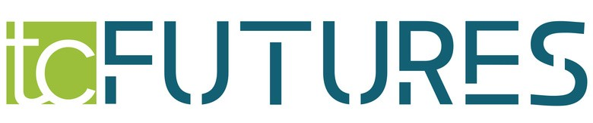
509-537-1710 www.tcfutures.org
2,652 Total Youth to visit TC Futures*
30 Completed GEDs
Out of School Youth
176 Total Youth Served
Total Youth who obtained employment and/or entered post secondary education
81
Total Youth who obtained Pre-
12 Apprenticeships with Labor International
Union of America

48 Total Youth Served
Total Youth who entered Registered Apprenticeships
5
Total Youth who obtained Pre-Apprenticeships with Labor International Union of America
6
*It is important to note that the TC Futures facility was not open to the public from the middle of March through June.

The Benton-Franklin Workforce Development Council is an Equal Opportunity employer/program. Auxiliary aids and services are available upon request to individuals with disabilities. Washington Relay: 711
BFWDC Staff
Tiffany Scott CEO David Chavey-Reynaud COO Jan Warren CFO
Diana Hamilton Workforce Programs Manager Cynthia Garcia Youth Programs Manager/
Equal Opportunities Officer
Jamilet Nerell Community Programs Manager
Becky Smith Office Manager
Jessie Cardwell Programs Coordinator

Serving Benton & Franklin Counties
for a Great Cause
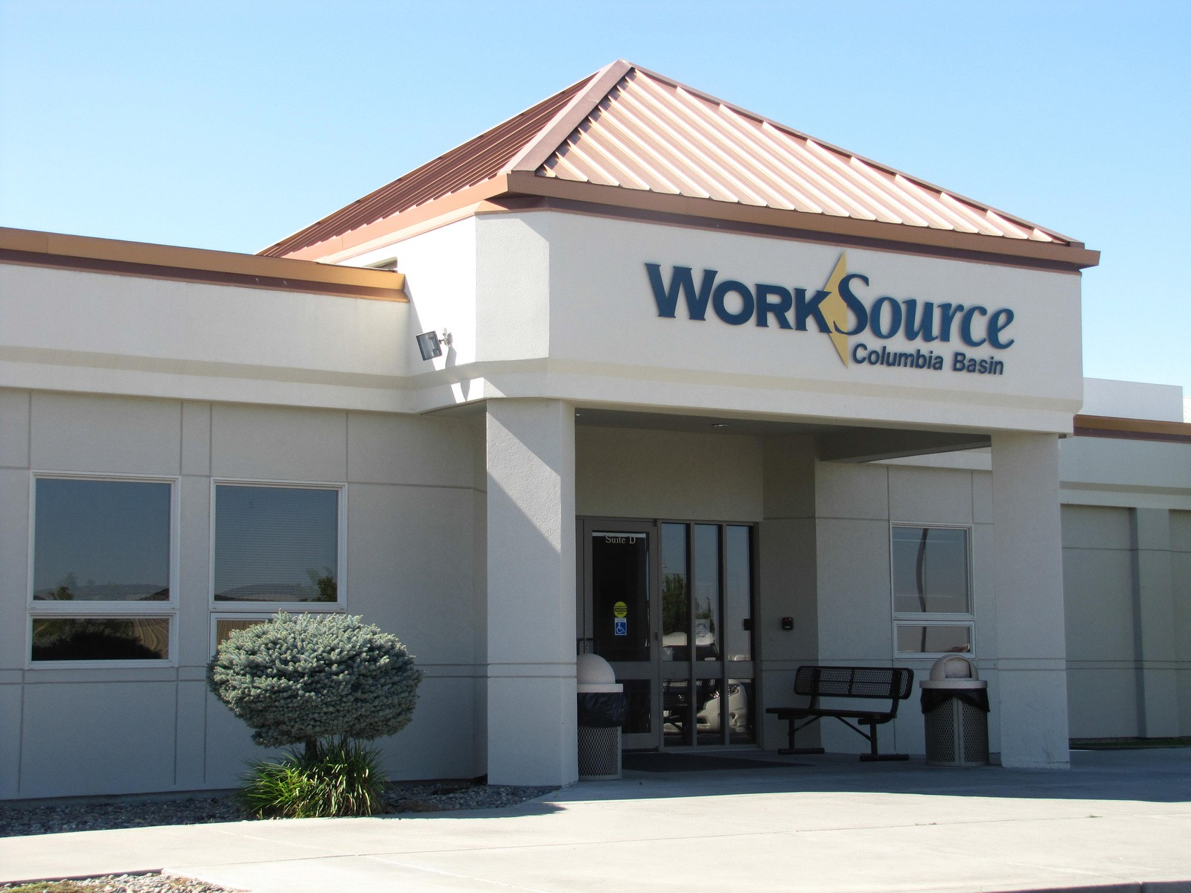Alfredo, entered the PY18 Rapid Response Increase Employment (RRIE) program in October 2019 as he was recently laid off due to a lack of work as Safety Coordinator with Apollo Heating and Air. Alfredo worked for several years with companies where he would be laid off, collect unemployment, and then be called back to work months later. Alfredo came to WorkSource for a scheduled RESEA appointment with the Employment Security Department (ESD). He disclosed to ESD staff that he was tired of having a job that was inconsistent throughout the years. ESD staff referred him to the RRIE program, where he was enrolled the same day. Alfredo stated he wanted a year-round position, and his goal was to obtain a Commercial Drivers License (CDL). PY18 RRIE paid for funding for Alfredo to get his CDL license. Alfredo completed training on December 9, 2019, and obtained his CDL license on January 4, 2020. After Alfredo obtained his license, he received a call from Advanced Technology Construction with a start date of January
27, 2020, making $38.46 per hour with full-time hours. Alfredo is thankful for the quick work and dedication of staff, helping him obtain a long-lasting career.

Theodore (Ted), came into WorkSource in August 2019 for a scheduled RESEA appointment with the Employment Security Department. Ted was unsure of how he was going to survive on unemployment and when he was going to find work again after being laid off from his previous job as a Commodities Trader at The Scoular Company, where he had worked for over twenty years. Staff identified that Ted might benefit from Worker Retaining and/or the Dislocated Worker program and encouraged him to attend the Dislocated Worker orientation. Ted was enrolled shortly after that. Ted received assistance with resume critique, job referrals, and encouragement through the arduous job search process. He also received support services to help with his household utilities and mortgage, as he was unsure how he was going to pay them and not fall behind. After being on unemployment for two months, he received a job as an Elevator Manager with Columbia Grain. This job required him to relocate to Pullman. The Dislocated Worker program provided relocation assistance for hotel accommodations while he secured stable housing in the area. Ted is earning a salary of $43.27 per hour with full health insurance benefits and four weeks of vacation annually.

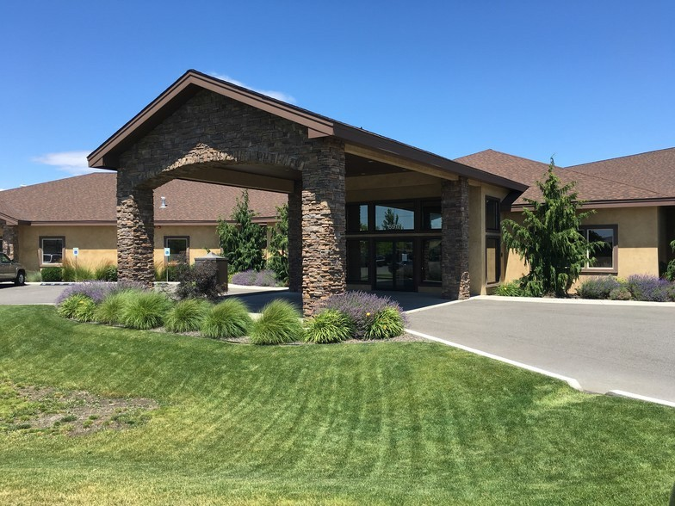Dmitry came to the program in need of his GED and employment/ training opportunities. His lack of a GED/High School Diploma had proved to be a barrier for Dmitry, and with the assistance of his Out of School Youth (OSY) and Open Doors case managers, Dmitry studied for and obtained his GED. Immediately after receiving his GED, Dmitry began the application process for the local Carpenter’s Union. Dmitry was accepted as an apprentice, and his OSY case manager assisted him in purchasing the necessary tools to start. Dmitry also received Financial Literacy services and Labor Market Information. In mid- November, Dmitry was hired as a Carpenter Apprentice by Balfour Beatty, working 40 hours per week at $20.16 per hour. As a member of the Carpenter’s Union, Dmitry had access to health benefits. As of mid-August, Dmitry has completed his first term of apprenticeship training and is now earning $25.05 per hour. He has expressed interest in mentoring other TC Futures customers by providing information on the benefits of Unions and assisting with the Carpenter’s Union application process.

