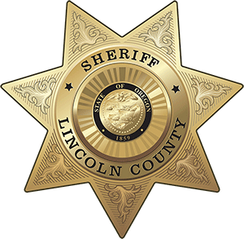
OFFICE OF THE SHERIFF

Sheriff Curtis L. Landers
225 W. Olive Street
Newport, Oregon 97365
(541) 265-4277
Fax (541) 265-4926

MEDIA RELEASE
FOR IMMEDIATE RELEASE

Date: November 30, 2020

Contact: Virginia “Jenny” Demaris, Emergency Manager
(541) 265-4199
vdemaris@co.lincoln.or.us

Community Response and Recovery Group Announcement - Lincoln County
(11.30.20 - Lincoln County)

Lincoln County Sheriff’s Office, Emergency Management Division, is extending invitations to local community and volunteer groups/agencies/individuals to build or create:

- LTRG for Echo Mountain Complex Fire – Long Term Recovery Group
- Long Term Recovery Committee or Group-a group that comes together to provide disaster assistance to individuals and households in both the immediate response through however long recovery lasts.
- COAD Group – Community Organizations Active in Disasters
- Community Organizations Active in Disaster (COAD)-generally the same purpose as a VOAD but may have more localized partners and are more comfortable utilizing the word Community
- VOAD Group – Volunteer Organizations Active in Disasters
- A consortium of recognized volunteer groups who work within a defined area (local, county, regional, etc.) in all phases of an emergency-generally in concert with a local Emergency Operations Plan.

Encouraged Community Partners/Groups/Agencies to Participate:

- Academic Organizations  - Civic Clubs  - Faith Community  - Food Assistance Groups  - Interpretation Services  - Neighborhood Associations | - Public Safety Volunteer Groups  - Social Service or Support Groups  - Trade or Industry Partners  - Other Community Service Groups  - Other Volunteer Groups  - Interested Individuals

Use this survey to let us know if you are interested in participating and how we can reach you:
- Survey Link: https://app.smartsheet.com/b/form/745a3ac4a72d46d3b6f312cc6f447f05
  - Each person in your organization that you want us to contact/add should complete the survey
- Next Steps: An introduction email will be sent for:
  - Echo Mountain Complex Fire Long Term Recovery Group first meeting week of Dec. 14th
  - Lincoln County COAD/VOAD Group kick off meeting to be scheduled in January.

You can learn more about these groups on our Lincoln County website at:
- https://www.co.lincoln.or.us/emergencymanagement/page/long-term-recovery-group-ltrg-voadcoad

Attachment: Invitation/Announcement 11.30.20

Example Long Term Recovery Group
Structure/Functions

###

Respectfully submitted,

Virginia "Jenny" Demaris
Emergency Manager
Lincoln County Sheriff's Office
Emergency Management
225 W. Olive St.
Newport, Oregon 97365
vdemaris@co.lincoln.or.us
(541) 265-4199 Office

