Media Release
Portland Water Bureau
For Immediate Release
Aug. 24, 2021
For more information, contact Public Information at 503-823-8064.
  - Plan ahead for trips to Washington Park—Next phase in reservoir project requires road closure
Visitors to Washington Park, including the Portland Japanese Garden and Portland International Rose Test Garden, should plan for limited parking options in September. The next step in the Washington Park Reservoir Improvement Project requires the Portland Water Bureau to close roads and some street parking in the area to restore hillsides that were modified during construction of the new reservoir. Easy access to parking is available using Washington Park’s free shuttle service.

Traffic impacts
Southwest Sacajawea and Sherwood boulevards will be closed to pedestrians, bicyclists and drivers from Tuesday, Sept. 7 to Friday, Oct. 1, 2021. The Water Bureau will remove support walls that are no longer needed to stabilize the hillsides near the project.
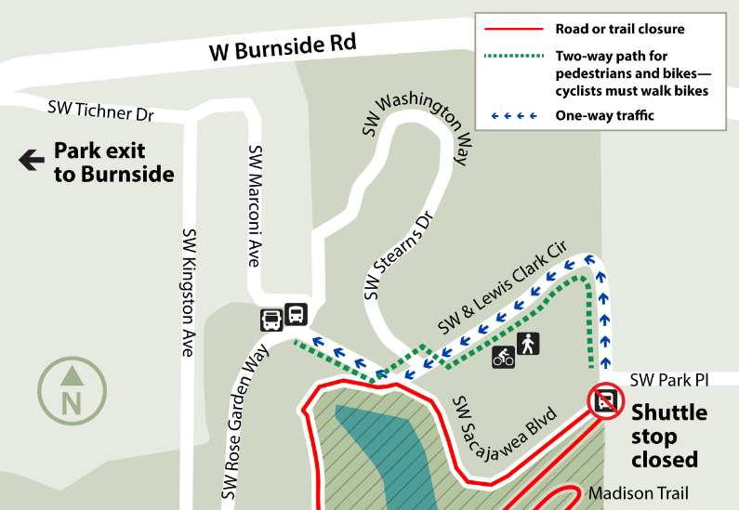
      - Southwest Sacajawea Boulevard between Southwest Park Place and its intersection with Southwest Sherwood Boulevard will be closed to all traffic.
- Southwest Sherwood Boulevard between Southwest Sacajawea Boulevard and Southwest Kingston Drive will be closed to all traffic.
- Madison Trail will be closed during this time.
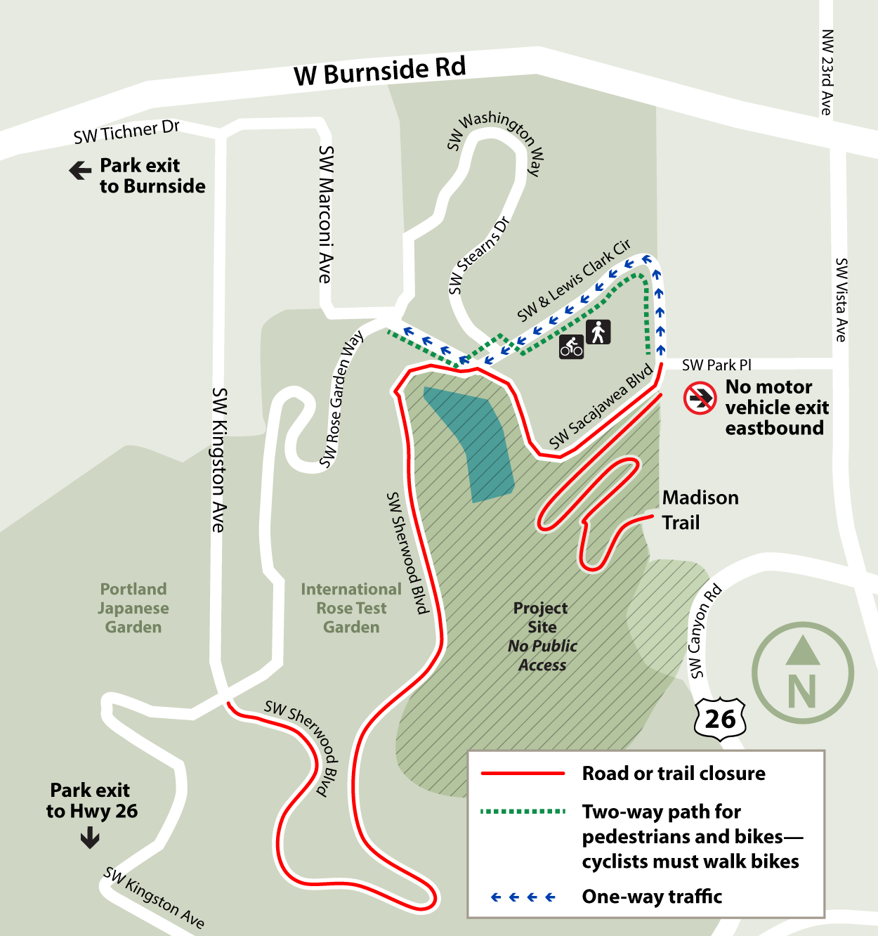

Visiting Washington Park? Plan ahead!
On-site parking near the Rose and Japanese gardens will be extremely limited. You are highly encouraged to use transit, including the free Washington Park shuttle, an enjoyable and efficient way to explore the park.

Parking
- Check real-time parking availability before you go. Pay to park via the Parking Kitty app or at pay stations.

Transit to the park
- Take MAX Light Rail Blue or Red lines or TriMet Line 63 to the Washington Park MAX Station, near the zoo. Or, park at the Sunset Transit Center and ride the MAX one stop to Washington Park. Make your transit plan here.

You’re at the park! Here’s what you need to know:

Pedestrians and cyclists
- The designated path separating pedestrians and cyclists from vehicles on Southwest Lewis and Clark Circle will remain open in both directions for travel into and out of the park.
- Cyclists will be required to walk bicycles on the path.
- Madison Trail will be closed.

Free shuttle in the park
- The Washington Park Free Shuttle runs a loop inside the park daily and stops at the Washington Park MAX Station. Use the real-time shuttle tracker to check its location and schedule. Visitors are encouraged to take MAX, TriMet bus service, or a rideshare service to Washington Park and connect with the shuttle. All shuttles are ADA accessible, and riders are required to wear masks.
- The Lewis and Clark Memorial Free Shuttle stop at the corner of Southwest Park Place and Lewis and Clark Way will be closed.

TriMet
- People using TriMet should check trimet.org for route or schedule changes.

Vehicles
- Entering the park: People travelling into the park from the city center may enter at Southwest Park Place and other access points in the area.
- Leaving the park: People travelling from Washington Park to the city center should take West Burnside Street or Highway 26 because of the Sherwood and Sacajawea Boulevard closures.

About the Washington Park Reservoir Improvement Project
The Portland Water Bureau replaced reservoirs that have served the city since 1894 with a new 12.4-million-gallon, seismically reinforced underground reservoir. When completed, this project will supply water to Portland’s west side and serve more than 360,000 people, including all downtown businesses and residents, twenty schools, five hospital complexes, and more than sixty parks. Learn more at portland.gov/water/WPReservoirs.

About the Portland Water Bureau
The Portland Water Bureau serves water to almost a million people in the Portland area. Portland’s water system includes two great water sources, 53 tanks and reservoirs, and 2,200 miles of pipes. With 600 employees working on everything from water treatment to customer service, the Water Bureau is committed to serving excellent water every minute of every day.

