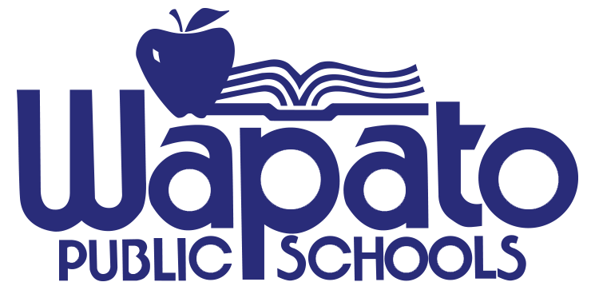 212 W. 3rd St. PO BOX 38 Wapato, WA 98951 509-877-4181
Kelly Garza, Superintendent

December 1, 2021

Contacts: Mike Balmelli, Community Relations Manager 509-307-4923/509-877-5019
Chris Beyrouty or Randy Wheeler, Wapato High School 509-877-3138

Wapato Robotics & Engineering Club
9th Annual Teriyaki Feed

No need to worry about fixing dinner at home this Saturday. You are invited to a teriyaki feed at Wapato High School. It is the Wapato High School Robotics and Engineering Club’s (WREC) 9th annual Teriyaki Feed. Proceeds are used by the club to help purchase materials, equipment and pay entry fees for the competitions the club participates in each year.

Wapato Robotics and Engineering Club (WREC) started competing in the FIRST Robotics Competition (FRC) in 2008. Wapato was the first school in Central Washington to form a team. Since then about 6 other teams have formed around the region.

In 2015 NASA HUNCH approached the Wapato Club to be a part of the NASA HUNCH program. At the time it was the only school in the Pacific Time Zone to work with NASA to help solve problems encountered on the International Space Station. Since then the Wapato Club has participated in both programs, NASA HUNCH and FRC. Additionally, in 2019 Wapato was on the winning alliance at the Sundome robotics competition, winning its first banner.

As a result of their experience in the club a number of Wapato students have gone onto college and pursued degrees in computer science, engineering, and communications. They have also gone on to work for companies like Boeing, Collins Aerospace, PayTrace and Facebook.

Who: Wapato High School Robotics & Engineering Club (WREC)
What: 9th Annual Teriyaki Feed
When: Saturday, December 4, 2021 from 4 pm to 8 pm.
Where: Wapato High School located at 1202 S. Camas Ave, Wapato, WA 98951
Cost: $12.00 per ticket

