Yamhill County

Sheriff’s Office
24 HOUR ALERT NUMBER: 503-434-7550
Information can be emailed to: whitlot@co.yamhill.or.us
Detective’s Bulletin
PC for Assault 1, Unlawful Use of a Weapon
The information contained in this bulletin is restricted to law enforcement only. This information is disseminated only for those in law enforcement with a valid right to know/need to know basis. Questions should be directed to the Yamhill County Sheriff’s Office Special Investigations Unit. Attn: Detective Sgt. Todd Whitlow Phone # 503-434-7506 or cell, 503-474-7343

Date: 02/03/2023 Agency Case Number: 23-0347

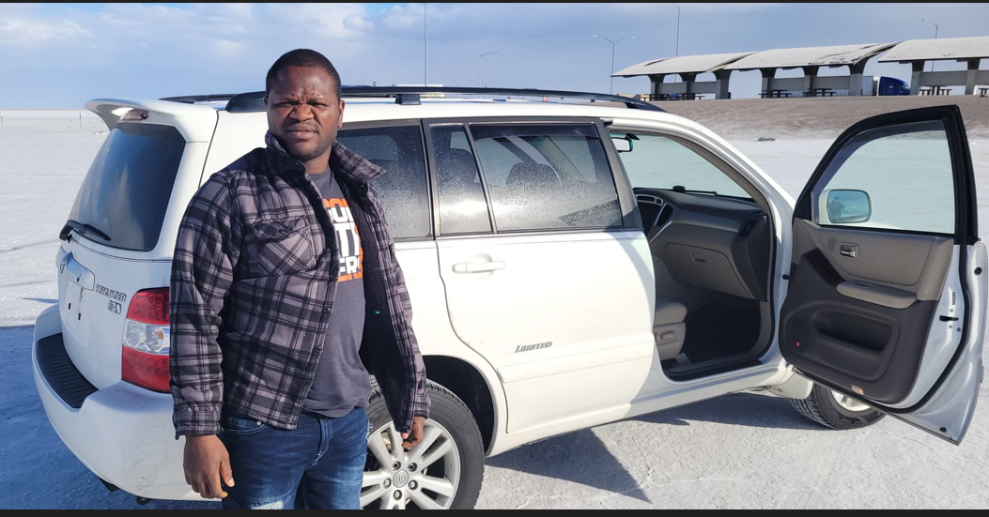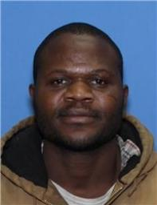

The Yamhill County Sheriff's Office is currently investigating an Assault 1/Unlawful Use of a Weapon, which occurred in the early morning hours on February 3, 2023. The suspect has been identified as Peter Darius Huber, DOB: 8/21/1989 and is depicted above. A temporary felony warrant has been issued for Huber. For 24-hour confirmation contact the Yamhill County Correctional Facility at 503-434-7507.
The above non-DMV photos are recent and were provided by family.
Huber’s whereabouts are currently unknown. He fled the scene in the above pictured 2007 Toyota Highlander. The year of the Highlander is 2007 and should be bearing Oregon license plate 148NUE. A court signed search warrant exists for the seizure of the above vehicle.
There is current information that Peter Huber could be suicidal, and it is unknown if he is armed at this time. Peter Huber should be considered a serious threat to others and has been entered in LEDs/NCIC as such.
Peter Huber’s whereabouts and direction of travel are currently unknown. He has family there, and may be in route to Chambersburg, Pennsylvania.
The Yamhill County Sheriff’s Office has PC for assault 1 and unlawful use of a weapon. If Peter is located, please detain on our Probable Cause, and contact Detective Sergeant Whitlow or the on-duty supervisor. Please do not interview or Mirandize Peter Huber until a YCSO Sergeant or Detective has been contacted.

