23-16921

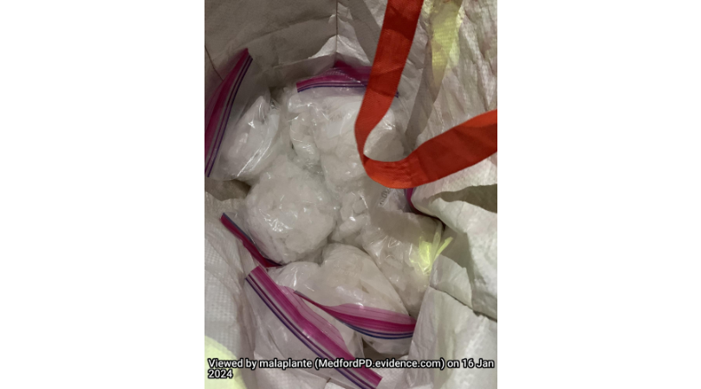

24-1876

24-2677

