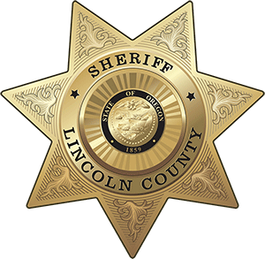
OFFICE OF THE SHERIFF

Sheriff Curtis L. Landers
225 W. Olive Street
Newport, Oregon 97365
(541) 265-4277
Fax (541) 265-4926

MEDIA RELEASE
FOR IMMEDIATE RELEASE

Date: May 26, 2020

Contact: Virginia “Jenny” Demaris, Emergency Manager
(541) 265-4199
vdemaris@co.lincoln.or.us

LINCOLN ALERTS COUNTY WIDE TEST SCHEDULED FOR JUNE 19, 2020
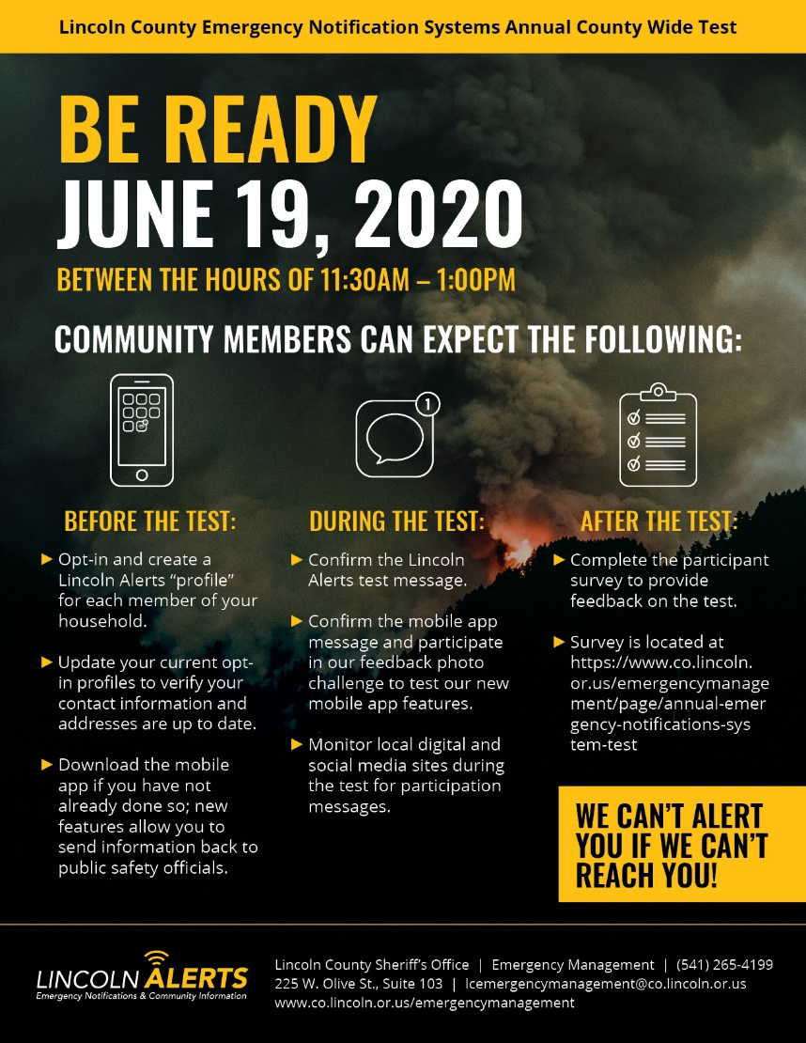
(05/26/20 - Lincoln County)
Lincoln County Sheriff’s Office – Emergency Management Division has scheduled an annual county-wide test of their emergency notification systems for June 19, 2020 between 11:30 am and 1:00 pm.

County Emergency Management will test all components of the Lincoln Alerts emergency notification system in preparation for seasonal wildfire conditions. A specific focus of the systems test will be on the Lincoln Alerts mobile app (powered by Everbridge) and the functionality of receiving information back from those who received the message.

Community members can participate in the county-wide test in the following ways:
- Pre-Test date:
  - Opt-in and create a Lincoln Alerts profile for each member of your household if you have not already done so.
  - Update your current opt-in profiles to make sure your contact information and addresses are up to date.
  - Download the mobile app and log-in (must have a Lincoln Alerts account first).
- During the Test:
  - Confirm the Lincoln Alerts test message on any of the devices in your profile or your residential or business landline phones.
  - Confirm the mobile app message and send back a photo through the mobile app to County Emergency Management confirming the ability to communicate to public safety officials during emergency events.
  - Monitor local media partner sites (radio, digital) during the test timeframe to confirm you received a notification through an alternative source.
- Post Test:
  - Complete the County Emergency Management on-line participant survey to provide feedback on the test.

County Emergency Management has several redundancies in place to push out emergency notification messages to those who may be in harm’s way due to emerging or imminent disaster situations. The county wide test allows County Emergency Management to test all features together just as it would be in a real disaster response situation. Those features include:

- Emergency Alert System (EAS) – message over local public radio systems
- Media release to local media partners (Flash Alert)
- Lincoln Alerts to opt-in profiles
- Lincoln Alerts to residential and business landline numbers
- Lincoln Alerts message specifically for mobile app users
- Lincoln Alerts message to community information Keyword subscribers
- Posting of emergency notification banner on county website (test message)
- New Facebook Alert Features

County Emergency Manager, Jenny Demaris, remarked

“Having the ability to test all of our emergency notification features and receive feedback from those we communicate to is incredibly important to County Emergency Management. It provides us a way to evaluate our systems, improve upon our processes and ensure we are ready when our communities need us.”

As part of the test, County Emergency Management is sponsoring a contest for users of the Lincoln Alerts mobile app (powered by Everbridge). App users who respond with a photo from one of the categories below will be entered to win a NOAA Weather Alert Radio sponsored by the National Weather Service. Six individuals will be randomly selected as winners. Winning photos will be shared on the Lincoln County Emergency Management Facebook page (@lcemergencymanagement).
- Mobile Phone App Photo Categories
  - Disaster Go Bags
  - Disaster home/work caches
  - Your NOAA Radio
  - Any tsunami evacuation signage, maps, etc.
  - Pets
  - Family
  - Co-workers
  - Summer activity
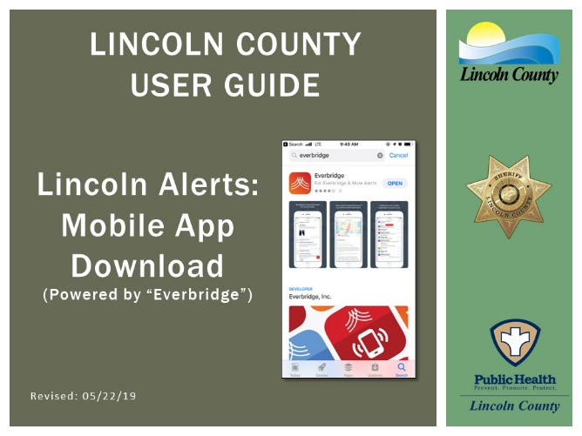

Lincoln Alerts User Guides Available

If you are new to Lincoln Alerts, need a refresher on how to update your profile or use the mobile app we have 3 handy user guides on our webpage to assigs you. The guides are intended to outline the steps needed to sign-up for Lincoln Alerts, download the mobile app and sign-up for the community keyword text messages. The user guides can be found at the Lincoln Alerts page at www.co.lincoln.or.us/alerts.

###

Respectfully submitted,

Virginia "Jenny" Demaris
Emergency Manager
Lincoln County Sheriff's Office
Emergency Management
225 W. Olive St.
Newport, Oregon 97365
vdemaris@co.lincoln.or.us
(541) 265-4199 Office

