OFFICE OF THE SHERIFF

Sheriff Curtis L. Landers
225 W. Olive Street
Newport, Oregon 97365
(541) 265-4277
Fax (541) 265-4926

MEDIA RELEASE
FOR IMMEDIATE RELEASE

Date: October 21, 2020

Contact: Virginia “Jenny” Demaris, Emergency Manager
(541) 265-4199
vdemaris@co.lincoln.or.us

LINCOLN COUNTY INFORMATION GUIDE: FLOODING UPDATED FOR 2020

(10.21.20 - Lincoln County)
Our flooding guide was specifically developed for Lincoln County communities by the Emergency Management Division of the Sheriff’s Office and provides the A-Z of information needed for before, during and after a flooding event occurs. The guide is intended as a one-stop shop on insurance opportunities, flood plain mapping, how to access current river level information, and how to protect yourself and your property. Important updates or reminders for this year:

Floods After Wildfire:
This year, an additional section was added; flood after wildfires. Heavy rain can produce flash flooding, debris flows, and mudslides in areas that have been burned by wildfires. When organic materials such as trees, scrub brush, plants, and litter on the forest floor burn at high temperatures, water repellant compounds are formed as vapors, and then condense onto cooler layers of soil below the hot fire.

This subsequently forms a layer of water repellant soils just below the surface, which prevents soils in the burned area from absorbing water after an intense wildfire. During heavy rainfall following a wildfire, water cannot penetrate the water repellant soil layer, which acts much like a layer of pavement, resulting in enhanced runoff of rainwater which can cause dangerous flash floods, debris flows, and mudslides.

Insurance:
Another important aspect of protection is reviewing your insurance policies to ensure you are adequately covered. The National Flood Insurance Program recently underwent a website upgrade and acts as a guide to property owners on insurance needs and benefits.

Flood insurance is not just for those property owners who live in the flood plain; it can protect many home and business owners from other events such as a tsunami or other water saturation events. Standard homeowners’ insurance may not cover these events.

Renters should also consider purchasing or updating their renter insurance policy to protect themselves from costs associated with damaged contents and/or if the Landlord is underinsured.

Updated Flood Plain Maps:
FEMA updated the Lincoln County Flood Plain Maps in 2020. This process is only completed once every 10 years. You can look up your address to see if you in the current flood zone by visiting FEMA’s website at https://msc.fema.gov/portal/search

The following is a list of the sections include in the flooding guide.

Table of Contents

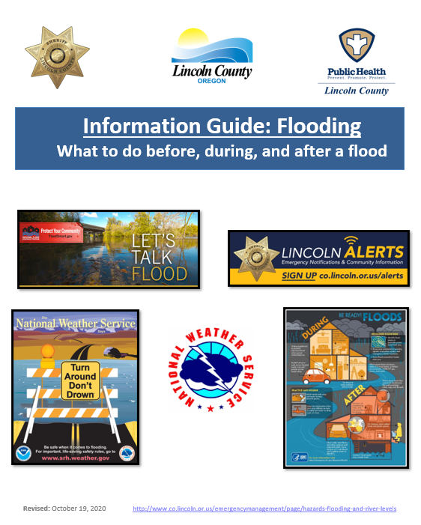
- Quick Links - Resource Information
- Emergency Notification Systems
- Weather, River/Tidal Forecasts, Observations and Historical Records
- Road/Travel Information
- Flood Plain Mapping – Viewing Your Flood Hazard
- Flood after Fire
- Insurance Programs
- Flood Readiness – Before, During and After a Flood
- Lincoln County Self-Serve Public Sandbagging Station and Resources
- Lincoln County Public Safety Information Guide

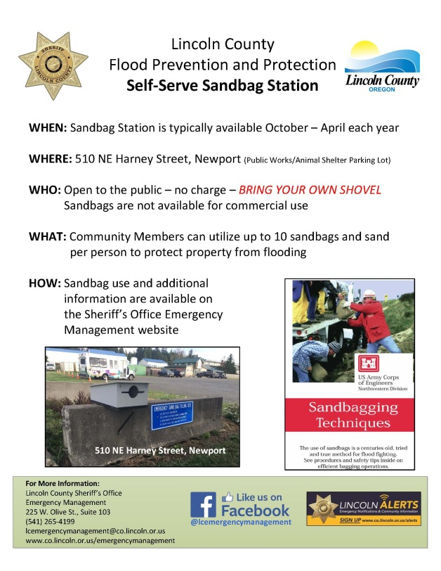
Lincoln County Self-Serve Public Sandbagging Station:

Sandbagging is one of the most versatile of flood fighting tools and is a simple, effective way to prevent or reduce flood water damage. Although sandbags do not guarantee a watertight seal, they are a proven deterrent to costly water damage. Sandbags have been used to:
- Prevent overtopping of levees
- Direct a river's current flow to specific areas
- Redirect storm water runoff to storm drains or redirect overflowing storm runoff drains from personal property
- Reduce seepage at closure structures

Location and Hours: Mid-October through mid-April
510 NE Harney St, Newport, access to sand is 24/7
Community members may pick up to 10 sandbags per person, per season. Those in need of more than 10 sandbags at a time are encouraged to reach out to local hardware stores and purchase them in advance. Community members are reminded protection of private property is the property owners’ responsibility and begins prior to storm events. If you have a water run off hazard or your home or structure is in flood path then you should assess your property in advance, educate yourself regarding sandbag quantities, sandbag placement techniques and the help you might need to accomplish the task. Properly placed, sandbags will redirect water and minor debris flow away from property improvements. Waiting until the water is at your doorstep is too late; there won’t be enough time or resources to effectively mitigate the water or debris run off.
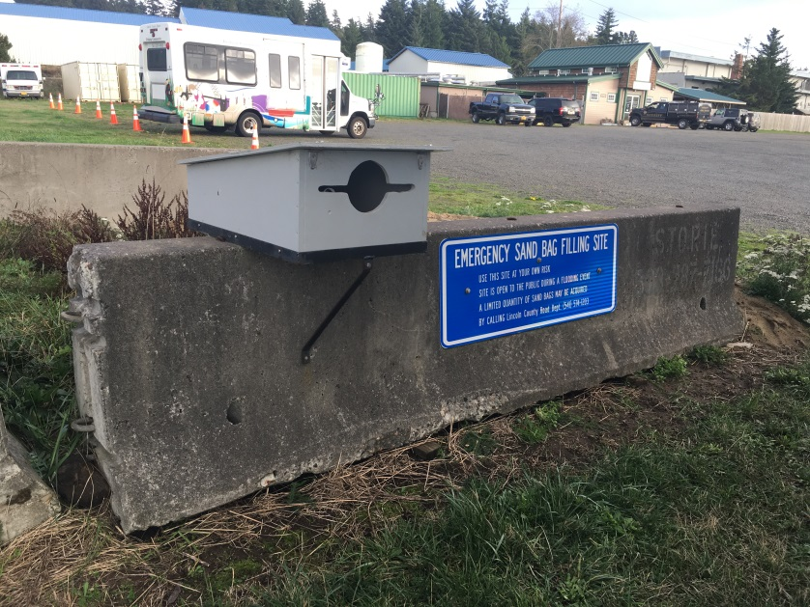

###

Respectfully submitted,
Virginia "Jenny" Demaris
Emergency Manager
Lincoln County Sheriff's Office
Emergency Management
225 W. Olive St.
Newport, Oregon 97365
vdemaris@co.lincoln.or.us
(541) 265-4199 Office

