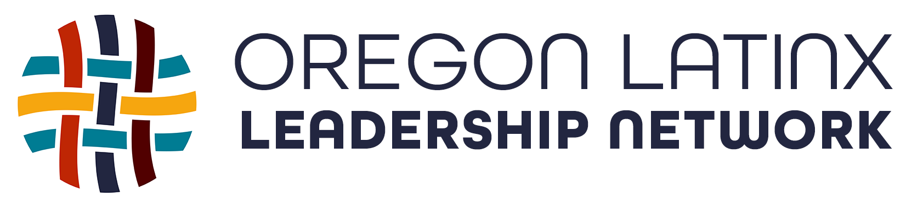

November 23, 2020
For Immediate Release
Contact:
Anthony Veliz, 503-953-2128
Aveliz@izomarketing.com

Oregon Latinx Leadership Network distributes needed PPE to Latino and indigenous communities

WOODBURN, Ore. – The Oregon Latinx Leadership Network (OLLN) recently launched a health and safety campaign, “Por Mi Familia,” to encourage Oregon’s Latino and indigenous populations to be safe during the coronavirus pandemic. They followed the launch with a purchase of five million pieces of personal protection equipment, or PPE, to distribute throughout Oregon to vulnerable Latino and indigenous communities to prevent the spread of COVID-19.

“We know wearing a mask can prevent the spread of the virus. However, purchasing much needed PPE can create a financial strain, and we are committed to helping people protect themselves from the virus,” said OLLN founder, Anthony Veliz. “Many of Oregon’s Latinos and indigenous are essential workers who are lacking new or proper PPE which puts them at a higher risk for contracting COVID-19.” The Oregon Latinx Leadership Network has partnered with the Oregon Child Development Coalition (OCDC) and the Oregon Human Development Corporation (OHDC) to distribute the PPE to many rural parts of Oregon.
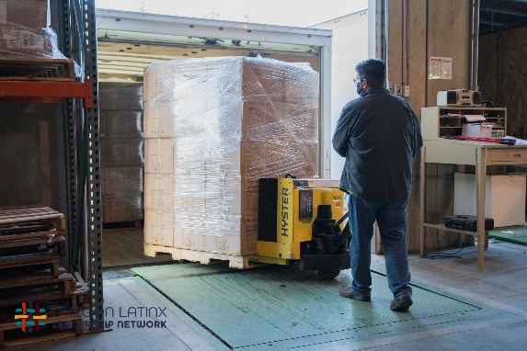
The OCDC serves families and children in 12 counties in Oregon. They offer services to support migrant and seasonal farmworkers and young children. Many of their clients are at or below the federal poverty level. “OCDC is pleased to partner with OLLN to get PPE to our families,” said Donalda Dodson, R.N., MPH, OCDC executive director. “Families are often responsible for purchasing these items and being able to provide them at no cost is helping to ensure people have masks and other items to keep them safe.”
The OHDC provides services for farm workers and disadvantaged individuals throughout Oregon. OLLN has partnered with this nonprofit human service organization to help distribute PPE to small businesses and over 50 community-based organizations that serve Latino communities. “OHDC is honored to partner with the Oregon Latinx Leadership Network to serve Oregon’s farm working community,” said Silvia Muñoz Lozano with OHDC’s National Farmworkers Program. “During this time of COVID, our farmworkers remain vulnerable to the spread of the virus. OHDC will ensure PPE is visible and accessible for one of Oregon’s most vulnerable essential workers.”
Veliz says the costs of masks, gloves, and other forms of PPE can created added stress on families, small business owners, and community-based organizations that serve the Latino community. “It is critical that we break down any barriers to help people get proper PPE. In Oregon, thirty-five percent of the people who contracted COVID-19 have been Latino. Affordability cannot be a reason for people not being able to protect themselves and their loved ones at home. This is what we should be doing during this unprecedented time: working together to solve problems and taking care of our communities.”
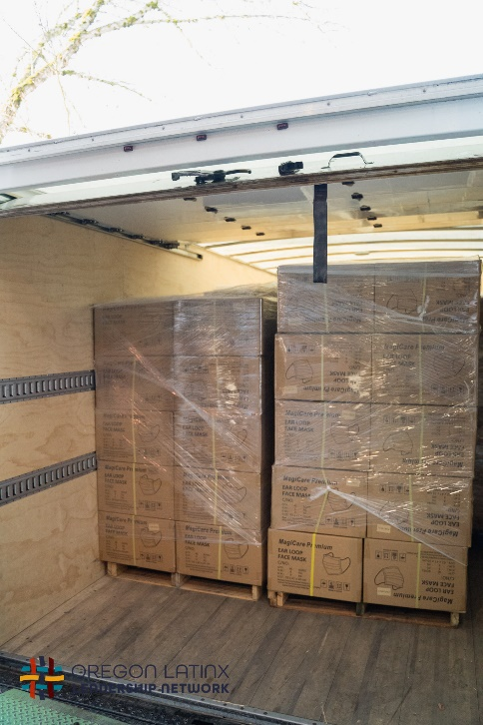
Photo credit: Jorge Rodriguez, OLLN
About the Oregon Latinx Leadership Network - The Oregon Latinx Leadership Network exists to build and strengthen community and resilience among our Latinx community, to organize and advocate around a strategic budget and policy agenda, and to partner with leaders and public officials to advance change to enhance the wellbeing of all Oregonians.

