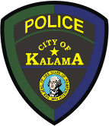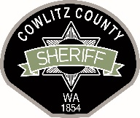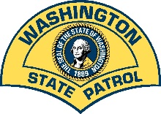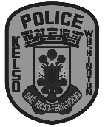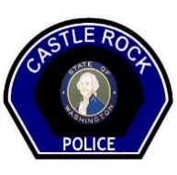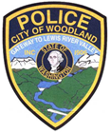

LOWER COLUMBIA MAJOR CRIMES TEAM
OFFICER INVOLVED SHOOTING INVESTIGATION
#A21-457

The Lower Columbia Major Crimes Team (LCMCT) is investigating an officer involved shooting, involving a Castle Rock Police Officer, that occurred on the night of February 28, 2021 in the Toutle, Washington area. This incident began as a report of a stolen commercial van, taken from a location in Lewis County. The van was equipped with GPS. Cowlitz 911 received information that the stolen van was actively moving near Spirit Lake Hwy.

The Cowlitz County Sheriff’s Office and Castle Rock Police Department were notified of this information. A Castle Rock Police Officer responded to the call and located the stolen van traveling on Spirit Lake Hwy near Seaquest Park. When the officer attempted to stop the van, it fled at a high rate of speed.

As the van continued Eastbound into Toutle, the driver stopped on the highway, reversed and struck the officer’s patrol vehicle. The driver turned Westbound and began to flee again as the officer pursued. The driver then stopped, drove in reverse again and rammed the officer’s vehicle a second time. The officer was injured and his vehicle was disabled. When the officer’s vehicle was struck, he dropped his primary duty weapon. The officer transitioned to his backup pistol and fired at the driver. Several bullets struck the van but neither the driver nor passenger were hit. The driver and the passenger both fled on foot.

Deputies and officers from several agencies responded to the area to assist. The driver of the van, identified as Dale E. Woodley, JR, age 40 of Longview, was detained by residents nearby after he unlawfully entered a trailer while attempting to evade capture. Deputies learned Woodley had also attempted to steal an all-terrain vehicle. The passenger, identified as Timothy R. Bean, age 33 of Longview, was located by a Longview Police K-9 and was taken into custody.

The officer is currently being treated for a spinal fracture. The Castle Rock Police Department patrol vehicle was extensively damaged and has been removed from service at this time.
Dale Woodley was booked into Cowlitz County Jail for Two Counts of Assault 2nd Degree, Attempting to Elude a Law Enforcement Officer, Possession of Stolen Vehicle, Malicious Mischief 1st Degree, Criminal Trespass, and Attempted Theft 3rd Degree. Timothy Bean was booked into Cowlitz County Jail for Possession of Stolen Vehicle.
The Lower Columbia Major Crimes Team was activated to investigate this incident per an Interlocal agreement. This incident does not fall under the requirements for the Independent Investigation Team protocol as described in Washington Administrative Code 139-12 and RCW 10.114.011 as the officer’s use of force did not result in death, substantial bodily harm or great bodily harm to the suspects. While the Lower Columbia Major Crimes Team will be conducting an independent investigation, the Family Liaison and Non-Law Enforcement Community Representative components will not be utilized in this investigation.

Troy Brightbill
Chief Criminal Deputy / Cowlitz County Sheriff’s Office
Commander / Lower Columbia Major Crimes Team
360-577-3092

