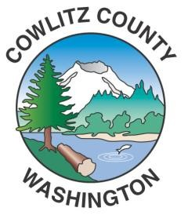

_____________________________________________________________________

Cowlitz County

News Release

April 1, 2021
Kelso, WA

State Auditor’s Office Investigation

In late 2018 complaints were made to Cowlitz County Human Resources Department and the State of Washington Auditor’s Office (SAO) concerning actions within the Cowlitz County Coroner’s Office. At that point the SAO commenced an investigation. Subsequent information concerning possible criminal activity was brought to the attention of the Cowlitz County Sheriff’s Office. The Sheriff’s Office referred the information to the SAO Special Investigations unit in part and to the Washington State Patrol (WSP) in part due to limits of the SAO’s purview in criminal matters not related to public funds. The engagement of outside agencies to investigate was done to avoid any appearance of a conflict of interest and to assure the public and the Coroner that an independent and objective investigation was conducted. While disappointed in the length of time it has taken to receive the results of the SAO fraud investigation we are confident in the integrity of the results and recommendations made in the report. WSP will be completing a criminal investigation report in the near future based on their investigation and that of the SAO. We are deeply concerned about the facts that have emerged from this process and have confidence that the process will move forward, respecting the public’s right to know what has occurred, as well as the Coroner’s right to due process.
The SAO report can be found at: https://portal.sao.wa.gov/ReportSearch/Home/ViewReportFile?arn=1027829&sp=false&isFinding=false#page=3

For further inquiries the SAO may be contacted as listed below:
Director of Communications Kathleen Cooper at (564) 999-0800.
Special Investigations Program Manager Stephanie Sullivan at (360) 688-0858.

