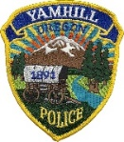
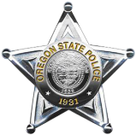
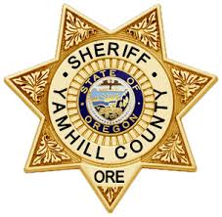
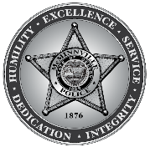
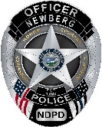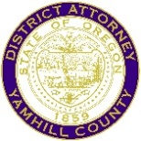

Yamhill County Multi Agency Traffic Team
Education - Collision Reconstruction - Enforcement

Press Release

On Saturday, July 24th, The Yamhill County Multi-Agency Traffic Team, which includes the Newberg-Dundee Police Department, will be conducting enhanced Speed and DUII enforcement operations in and around the Newberg area to coincide with the Newberg Old Fashioned Festival events. Units will be focused on traffic safety issues and will become increasingly visible on the Highway 18 Bypass throughout the evening. Please stay alert on the roadways and be aware of increasing vehicle and pedestrian traffic in the area. We hope you all have a safe and enjoyable weekend.

Release created by: Sgt Eric Ronning, Newberg Dundee Police Department, (503)-537-1226

