OFFICE OF THE SHERIFF

Sheriff Curtis L. Landers
225 W. Olive Street
Newport, Oregon 97365
(541) 265-4277
Fax (541) 265-4926

MEDIA RELEASE
FOR IMMEDIATE RELEASE

Date: August 31, 2021

Contact: Jenny Demaris, Emergency Manager
vdemaris@co.lincoln.or.us
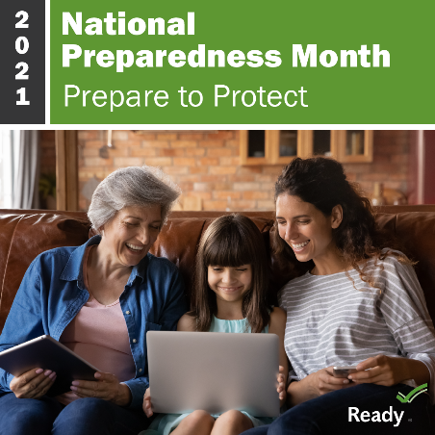
(541) 265-4199 Office

SEPTEMBER - NATIONAL PREPAREDNESS MONTH

Lincoln County Sheriff’s Office and Lincoln County Public Health are pleased to promote and locally support the 2021 National Preparedness Month (NPM) campaign.

National Preparedness Month is recognized each September to promote family and community disaster planning now and throughout the year. This year’s NPM theme is “Prepare to Protect. Preparing for disasters is protecting everyone you love.” A fitting theme during the COVID-19 pandemic, local droughts, and while reflecting on the 2020 wildfires.

Local governments and partners work continuously to prepare for emergencies on a community level. This preparation does not replace the need of preparing yourself and family. Emergency preparedness on an individual level is an important step to ensure disaster resiliency. Talk to your friends and family about how you will communicate before, during, and after a disaster. Consider updating your personal and family plans based on the Centers for Disease Control recommendations for coronavirus and refresh your emergency food, water, and medications. This is a good time to make sure your plans and supplies meet your needs if you or someone in your house has a disability. Taking time now to ensure they will have backup mobility supplies or can properly store and access life-saving medications can make all of the difference later.

2021 NPM Weekly Themes
- Week 1: Sept 1-4 Make a Plan
- Week 2: Sept 5-11 Build a Kit
- Week 3: Sept 12-18 Low-Cost, No-Cost Preparedness
- Week 4: Sept 19-25 Teach Youth About Preparedness

Examples of emergency preparedness activities for youth on www.ready.gov/kids.
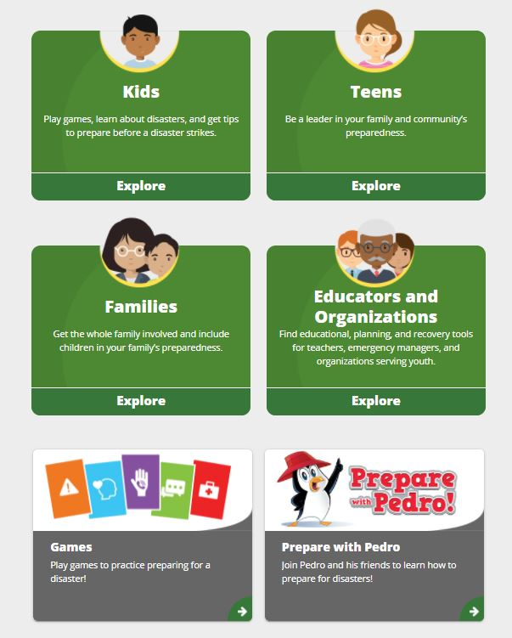

Lincoln County Emergency Management Webinars

In lieu of in person activities, Lincoln County Emergency Management has recorded several virtual sessions to help our communities prepare. Although these presentations were originally created for wildfire preparedness, the content applies to all hazards.

Lincoln County Emergency Management Videos:

- Module 1 - Financial and Business Preparedness
  - Presentation Slides: Financial and Business Preparedness
  - Video Recording: Recorded Version

- Module 2 - Animal Preparedness (Pets and Livestock)
  - Presentation Slides: Animal Preparedness
  - Video Recording: Recorded Version

- Module 4 - Emergency Notifications & Evacuation Processes
  - Presentation Slides: Emergency Notifications and Evacuations
  - Video Recording: Recorded Version

- Module 5 - Sheltering with the American Red Cross and Medically Fragile Persons
  - Presentation Slides: Sheltering with the American Red Cross and Medically Fragile Persons
  - Video Recording: Recorded Version
- Module 6 - Air Quality Considerations and Access and Functional Needs Persons Preparedness
  - Presentation Slides: Air Quality Considerations, Access and Functional Needs Persons Preparedness
  - Video Recording: Recorded Version
American Red Cross Cascades Region Webinars

The American Red Cross of the Cascades Region offers virtual programs to help adults and children better prepare for emergencies.
Red Cross Presentations and Videos:

- Be Red Cross Ready – Home Fire Preparedness
  - Recorded Emergency Preparedness Webinar: here
- EN ESPAÑOL: Taller virtual de preparación para huracanes e incendios
  - Recorded Emergency Preparedness Webinar: here
- Be Red Cross Ready – COVID 19
  - Recorded Emergency Preparedness Webinar: here
- The Pillowcase Project
  - An interactive preparedness program designed for children in grades 3 through 5.
  - Request a free presentation here.
- Be Red Cross Ready
  - Basic preparedness information including how to make or build a preparedness kit, make an emergency plan with your family and learn what to do before, during and after disasters of all kinds, including the COVID-19 pandemic.
  - Request a free presentation here.

###

Respectfully submitted,

Virginia "Jenny" Demaris
Emergency Manager
Lincoln County Sheriff's Office
225 W. Olive St., Newport, Oregon 97365
vdemaris@co.lincoln.or.us
(541) 265-4199 Office

