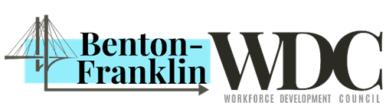



***Virtual Holiday Hiring Event***

Kennewick, WA. October 12, 2021

**Are you looking for work? WorkSource Columbia Basin is hosting a free virtual hiring event on Thursday, October 21st, from 10am-1pm.**

There will be a variety of employers available. This is a great opportunity to inquire about open positions and talk with the hiring managers directly. You won’t want to miss it!

Register for the event and upload your resume today at: <https://bit.ly/3ATCZ8h>. For a list of participating employers and to stay up to date on events and services, follow us on Facebook.

**Are you a business who is hiring and looking for qualified candidates? We’d love for you to join us!**

WorkSource is providing a FREE Virtual Job Fair to help you connect to job seekers! If you are looking for your next great hire, join this free event to talk with candidates who want to join your team.

To sign up for a booth, contact the Business Services team at WSCBEmployers@esd.wa.gov or 509-734-5953.

***WorkSource Columbia Basin is available to serve you by phone, appointment, or virtually. We provide resume assistance, interview preparation, online workshops, and much more! Contact us at 509.734.5900 or go online to*** [***www.WorkSourceWA.com***](http://www.WorkSourceWA.com) ***to learn how we can help. Follow us on Facebook to stay up to date on events and services.***

⎯ ### ⎯

For press only

Crystal Bright

509-734-5887

Email address: [cbright@esd.wa.gov](mailto:cbright@esd.wa.gov)