Kenneth William Peden III Committed Suicide Awaiting Trial For The Murder of Gervais Teenager

On April 20, 2021, the parents of 17-year old Molly Taylor, also known as Oliver, reported him missing as a possible runaway. The Gervais Police Department, Marion County Sheriff’s Office, and Deschutes County Sheriff’s Office investigated the report and, after eight days, Oliver was located near Redmond, Oregon, with 20-year-old Kenneth William Peden III. Oliver was returned home to his parents.

On the evening of May 8, 2021, Marion County Sheriff’s Office deputies responded to the Taylor residence in Gervais on a report that Peden, having been previously told to not have contact with Oliver or return to the property, was refusing to leave the property. The incident was referred to the Gervais Police Department and after a full investigation, Peden was cited for criminal trespass in the second degree. Peden was also cited for custodial interference for taking Oliver from Gervais to Redmond in the April incident. Peden was advised by officers, and again by Oliver’s parents, that he was not allowed to return to the Taylor residence or have any contact with Oliver.

On May 12, 2021, around 4:47pm, Oliver was preparing to drive from his house in Gervais with his mom Erin Taylor in the front passenger seat and his 22-year-old friend Arik Reed in the back seat. As the three sat in a car in the driveway of the Taylor home, Peden parked his truck a few houses down the street and walked up to the driver side of the car demanding Oliver get out of the car. Mrs. Taylor got out of the front passenger seat and confronted Peden outside the driver side of the car telling him he was not supposed to be there and to leave. Peden continued to tell Oliver to get out of the car, threatening that the only way Peden would leave is if Oliver left with him. Mrs. Taylor began to yell to Oliver’s brothers, who were inside the house, that Peden was there and was refusing to leave.

Peden momentarily walked away from the car and into the road where he pulled out a handgun from his front pants pocket. Peden walked back to the driver side of the car displaying the handgun and demanded that Oliver get out of the car. Mrs. Taylor, still outside next to the driver side of the car, screamed that Peden had a gun as Oliver also screamed, refused to get out of the car and locked the car doors. Peden walked around to the passenger side of the car trying to open those doors and violently hit the front passenger window multiple times with his arm holding the handgun until the window broke. Peden walked back to the driver side of the car and pulled Oliver out of the driver seat. Arik Reed immediately got out of the back seat displaying a knife to stop Peden from taking Oliver. In response, Peden shot Reed in the abdomen and took Oliver to Peden’s awaiting truck down the street. Mrs. Taylor chased after them pleading with Peden to not take Oliver. Peden ignored these pleas and instead forced Oliver into the cab of his truck and then sped away with Oliver in the front passenger seat.

Oliver’s brother, neighbors, and Reed called 911 for help. Reed made it from the driveway to the front porch of the Taylor home where he slumped to the ground as Mrs. Taylor and Oliver’s brothers rendered aid. At 4:53pm, officers from the Gervais Police Department arrived at the Taylor home, rendered aid to Reed, and continued to relay information to dispatchers about the details of the shooting and kidnapping.

Law enforcement officers from the Marion County Sheriff’s Office and Silverton Police Department located and became involved in a pursuit of Peden and attempted rescue of Oliver. Senior Deputy Ron Cereghino of the Marion County Sheriff’s Office located and pursued Peden’s truck from Mt. Angel into the city of Silverton. Soon after Peden entered the city of Silverton, Sergeant Jonathan Lamoreaux and Officer Braden Andersen of the Silverton Police Department joined in the pursuit of Peden.

Peden was driving recklessly almost hitting other vehicles and fired multiple rounds toward pursuing police officers as they traveled through the city of Silverton. There were people, including children, outside and in the area Peden was shooting at pursuing police officers. Multiple casings were located in Silverton on 2nd Street and a resident on the corner of 2nd Street and High Street reported finding a bullet hole in his garage door from the shooting. At no time did officers have an opportunity to safely return fire toward the speeding truck. As Peden drove toward Highway 214 out of Silverton, a witness who was in his front yard watched Peden speed by with Oliver in the front passenger seat signaling for help.

As the truck sped up the winding Highway 214, Peden drove in to the oncoming lane of traffic and crashed into a truck pulling a trailer causing significant damage to the trailer. Peden continued to drive his now damaged truck until it finally came to a stop on Highway 214 near Forest Ridge Road NE. As officers approached Peden’s stopped truck, he continued to shoot at them. As the officers were taking fire from Peden they stopped their vehicles a few feet away, physically took positions behind their opened police vehicle doors and returned fire toward Peden. Peden remained seated in the driver seat of his truck as he turned toward officers and fired shots. Other officers arrived and took positions behind Lamoureux, Andersen, and Cereghino.
Peden eventually surrendered and was detained by law enforcement officers. None of the law enforcement officers’ shots struck Peden or Oliver. Peden had minor visible injuries to the side of his face and ear from shattered truck window glass. Although multiple police vehicles were struck by Peden’s gunfire during the incident, no law enforcement officers were injured.
Officers and medics found Oliver slumped over in the front passenger seat of Peden’s truck with a life-threatening close contact gunshot wound to the face and immediately rendered aid. Oliver was transported by helicopter Life Flight from the scene. Oliver later died on May 19, 2021, as a result of the single gunshot wound at Doernbecher Children’s Hospital.
As previously released, the Oregon State Police led the investigation which was presented to a Marion County grand jury on May 20, 2021. The grand jury, in applying the legal standard to the testimony and evidence presented, found that each officer was justified in using deadly force against Peden.
The same grand jury that found the officers’ actions to be justified also indicted Peden for the intentional murder and kidnapping of Oliver, the attempted murder of Arik Reed, the attempted murder of four (4) law enforcement officers, and the felony attempting to elude a police officer. His charges were as follows:

- Murder in the First Degree with a Firearm
- Kidnapping in the First Degree with a Firearm
- Attempted Murder in the Second Degree with a Firearm
- Assault in the First Degree with a Firearm
- Attempted Murder in the First Degree with a Firearm
- Attempted Murder in the First Degree with a Firearm
- Attempted Murder in the First Degree with a Firearm
- Attempted Murder in the First Degree with a Firearm
- Fleeing and Attempting to Elude a Police Officer

Peden was in custody at the Marion County jail awaiting trial on the above charges set to begin May 16, 2022. On September 22, 2021, Peden was found by Marion County Sheriff’s Office deputies hanging unresponsive in his single cell. Deputies, jail medical staff and responding paramedics attempted to resuscitate Peden for approximately 40 minutes before declaring him deceased. The Marion County Sheriff’s Office requested the Linn County Sheriff's Office conduct the investigation into Peden’s death. The Linn County Sheriff’s Office concluded its investigation at the end of October and forwarded its findings to the Marion County District Attorney’s office for review. After a full review of the investigation, the Marion County District Attorney’s office concludes that Peden’s manner of death was suicide. The criminal case has been dismissed.

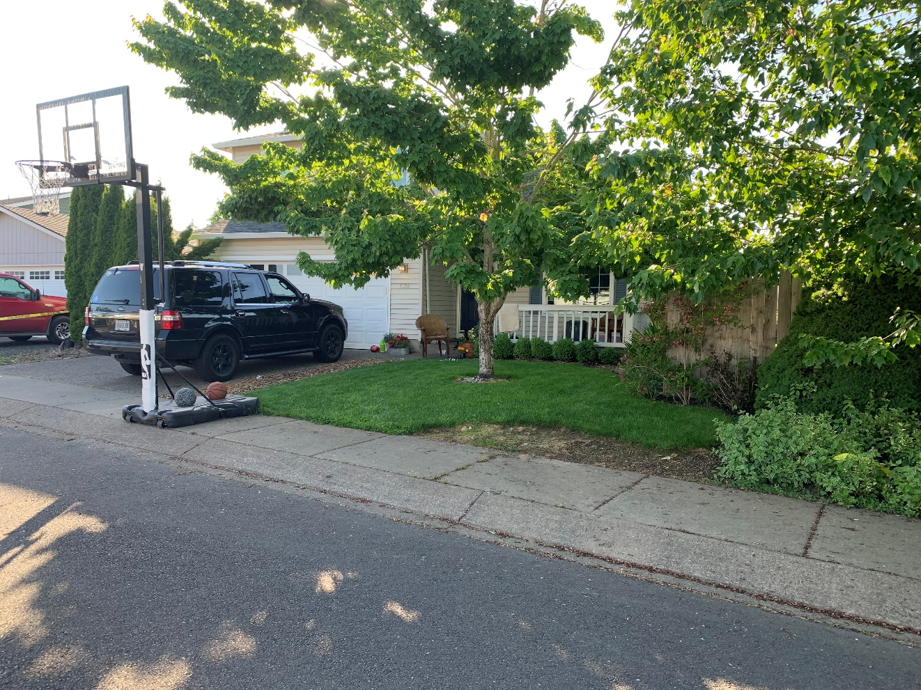
Vehicle with broken out front passenger window by Peden in driveway of Taylor home in Gervais where Peden shot Reed and kidnapped Oliver.

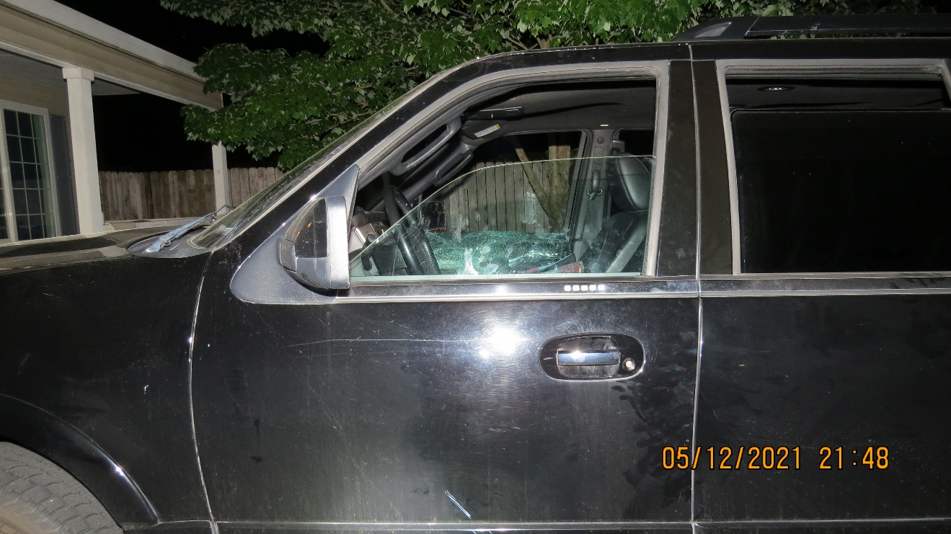
View of front driver side of vehicle where Oliver was seated with Reed in the back seat when Peden smashed in the front passenger window.
.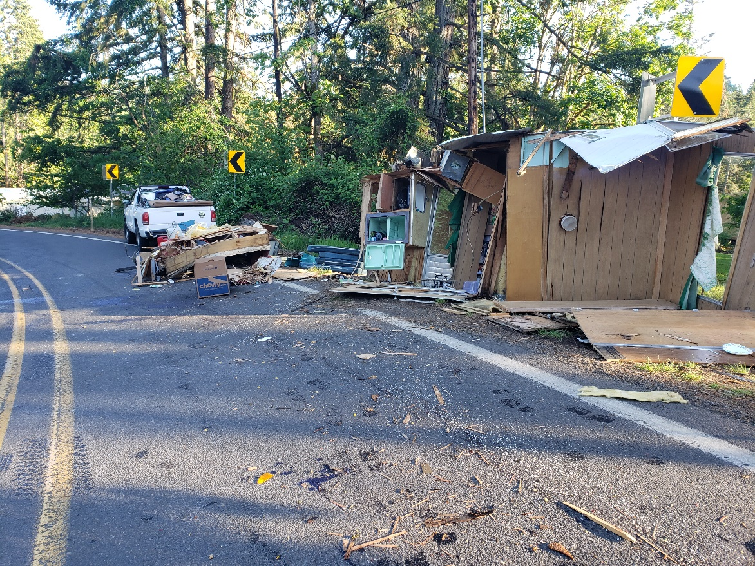
The truck and trailer Peden crashed into on Hwy 214 as he eluded pursuing police officers from Mt.Angel through Silverton.

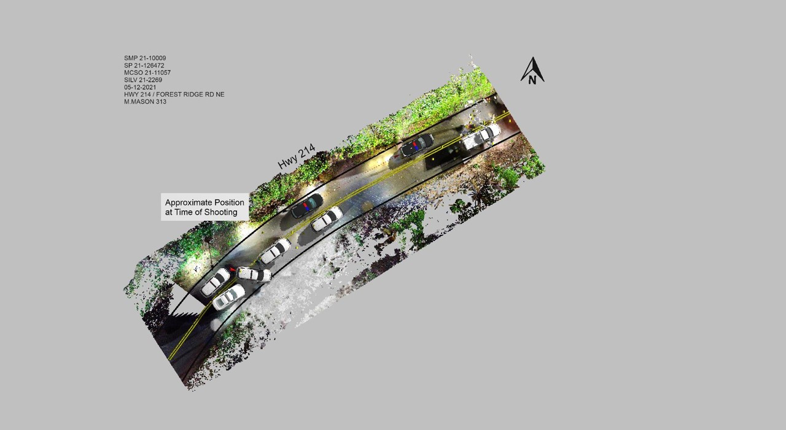
Visual aid of the position of vehicles at the time of and after the shooting. The position of Marion County Sheriff’s Office Deputy Cereghino’s patrol vehicle (black vehicle) moved forward after Peden surrendered. Cereghino’s patrol vehicle was used and moved toward Peden’s truck as safe cover for officers during the approach to detain Peden. The position of Silverton Police Department Officer Finnegan’s patrol vehicle (white with red mark in front) moved forward and diagonal behind Officer Andersen’s vehicle to make room for emergency medical vehicles.

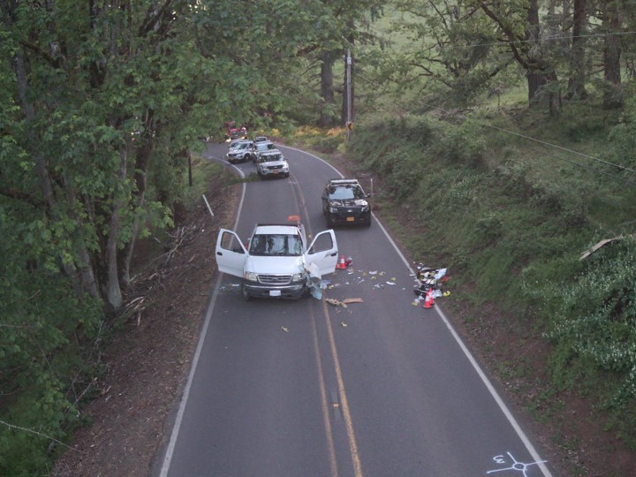
Approximate position of vehicles after the arrest of Peden and rescue of Oliver.
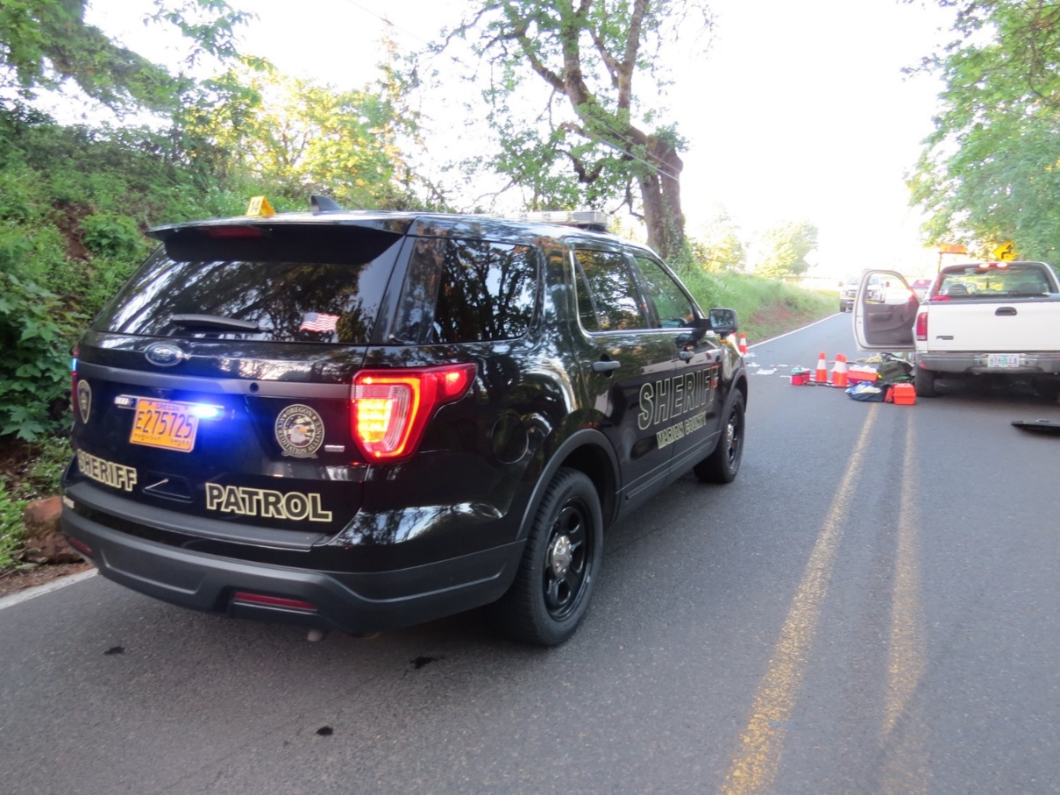
Deputy Cereghino’s police vehicle on scene facing Peden’s truck.

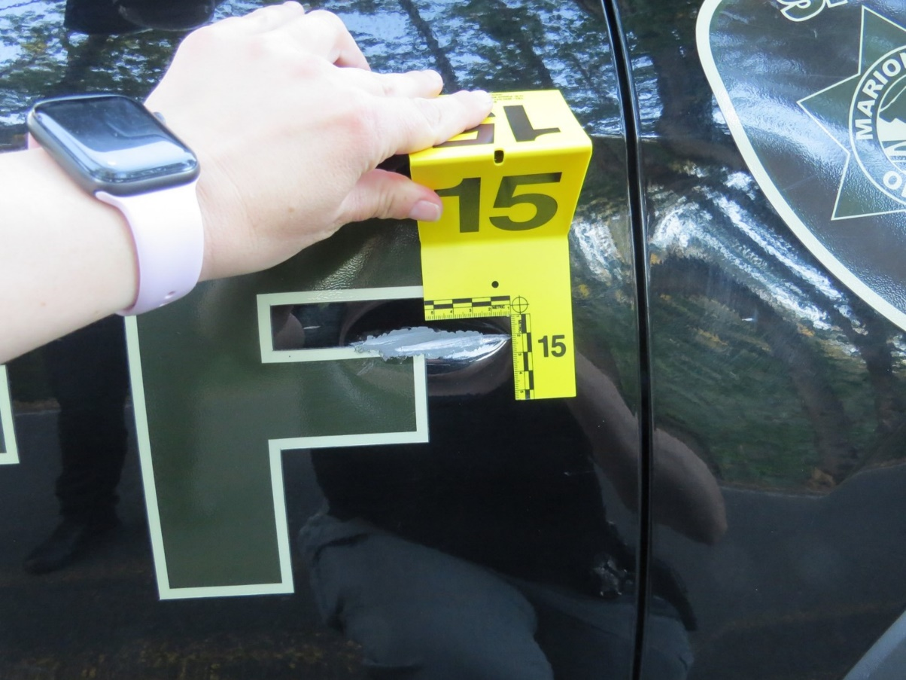
Damage to Deputy Cereghino’s police vehicle from Peden shooting at him.
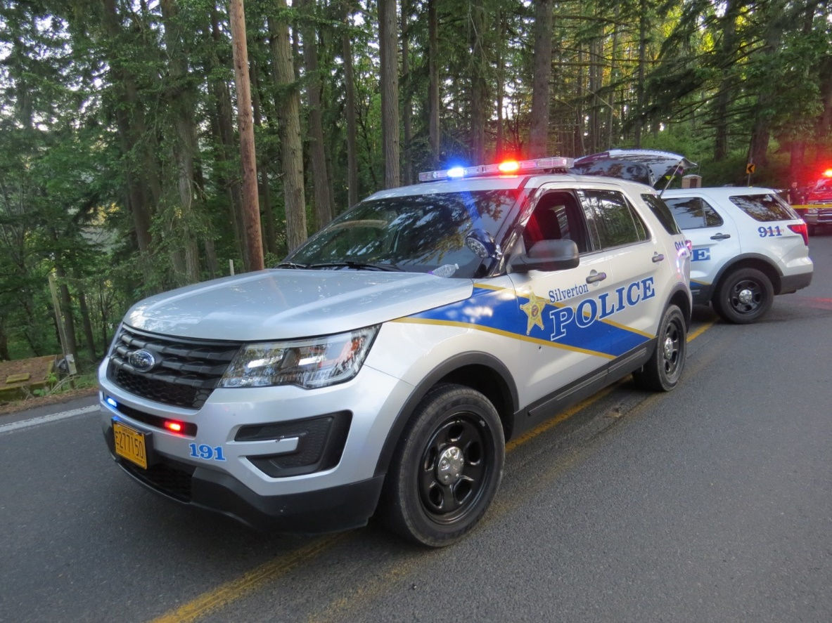
Officer Andersen’s police vehicle on scene, with Officer Finnegan’s police vehicle behind it.
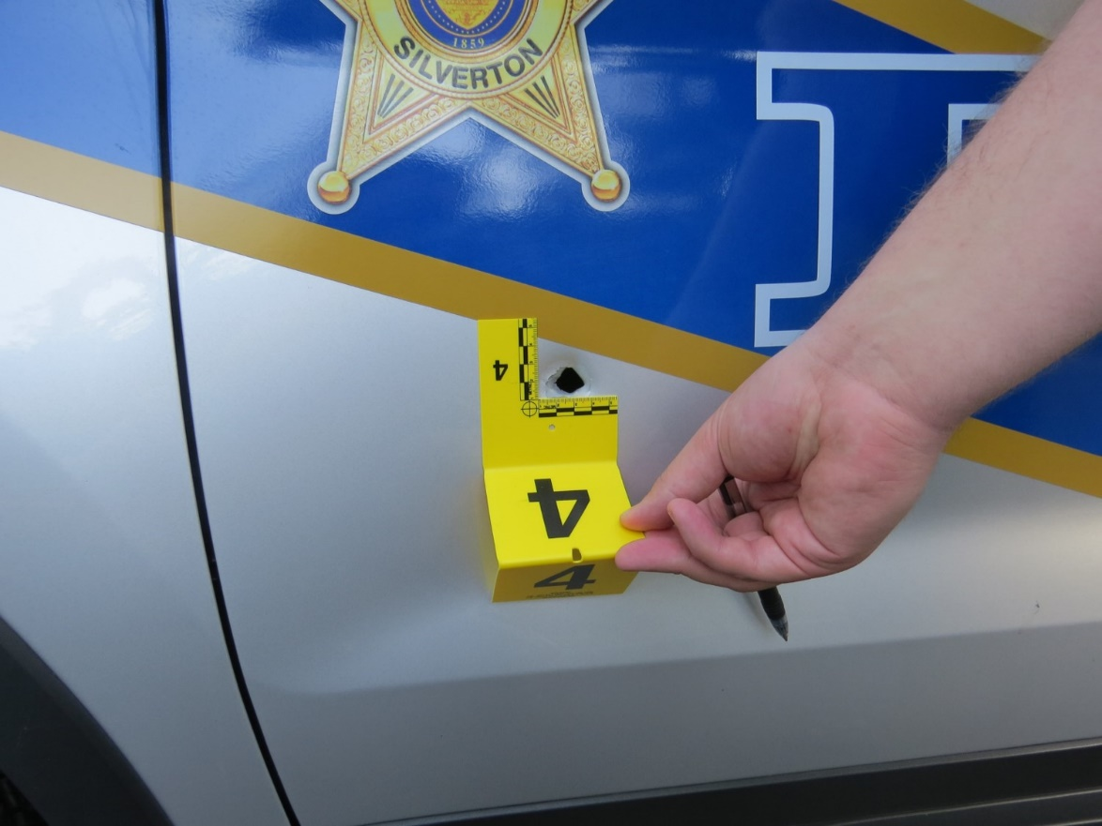

Bullet hole in Officer Andersen’s police vehicle from Peden shooting at him.
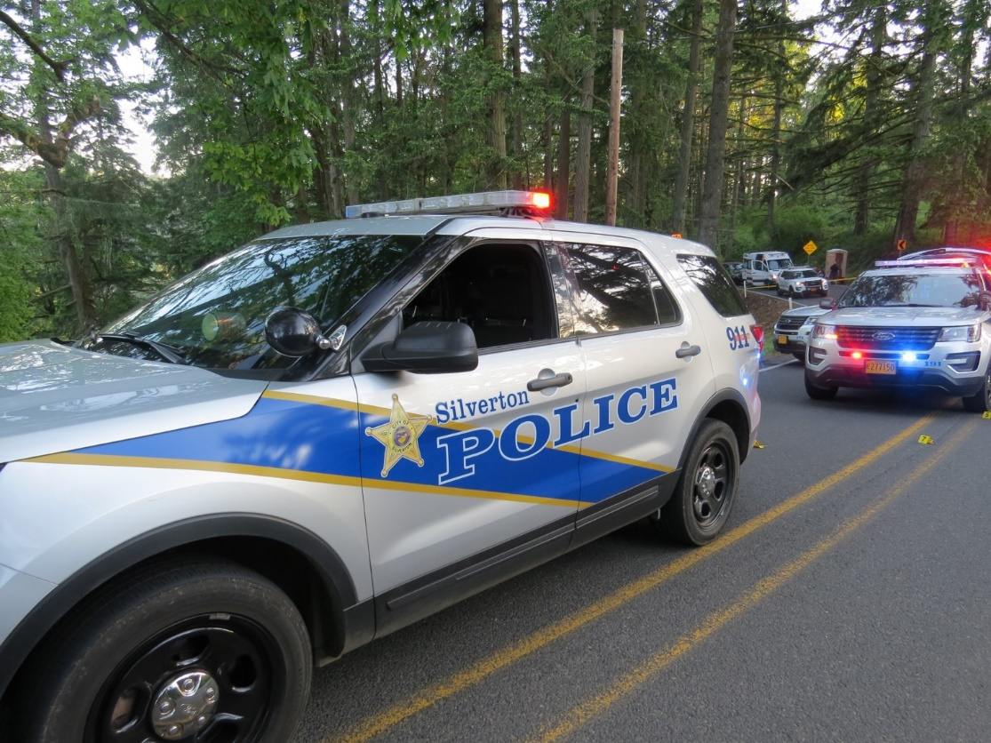
Officer Lamoreaux’s police vehicle on scene, with Officer Andersen’s police vehicle behind it.

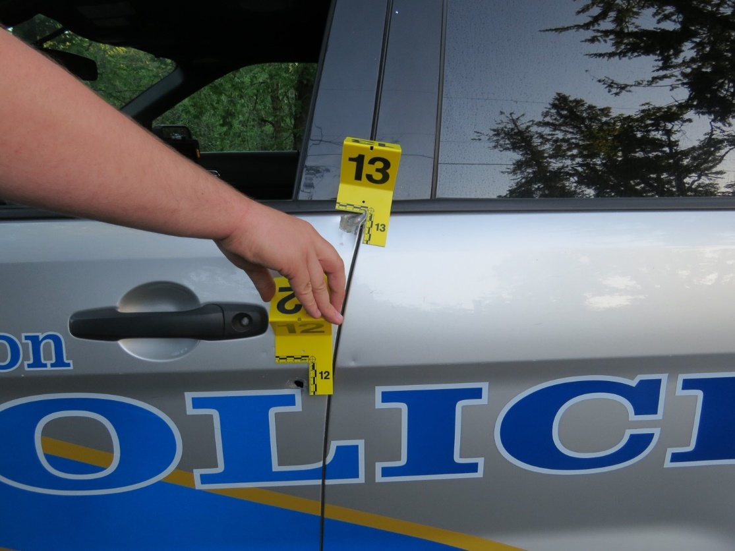
A graze and a bullet hole to Officer Lamoreaux’s police vehicle from Peden shooting at him.
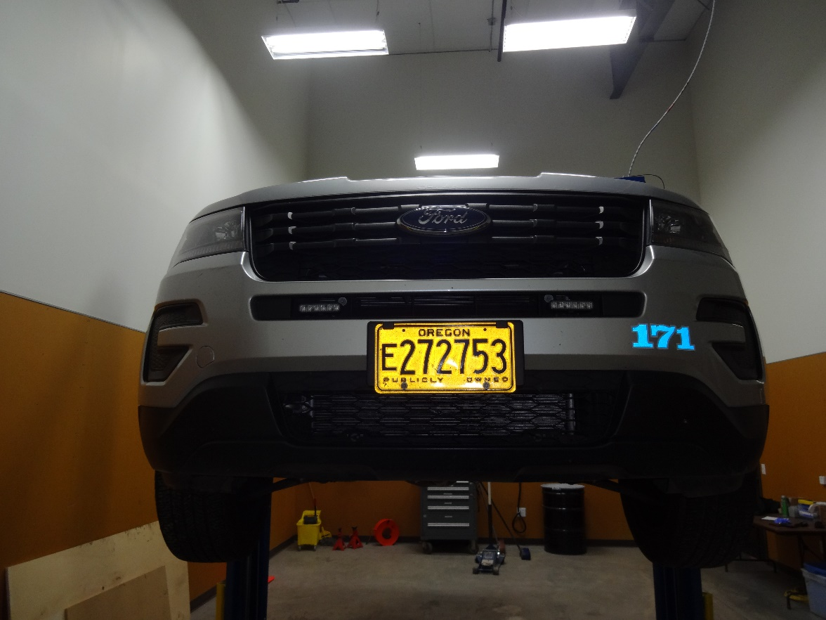
Officer Finnegan’s police vehicle being examined after the incident.

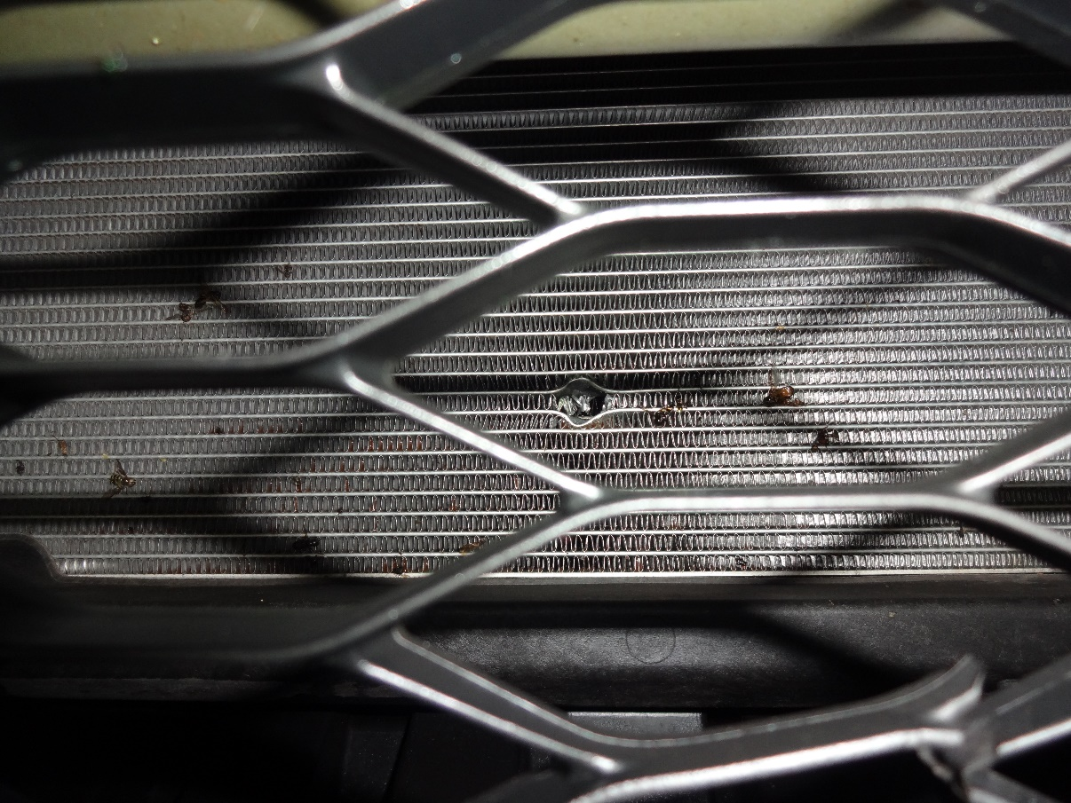
Bullet hole and bullet fragments discovered in front grill of Officer Finnegan’s police vehicle from Peden firing at police officers.
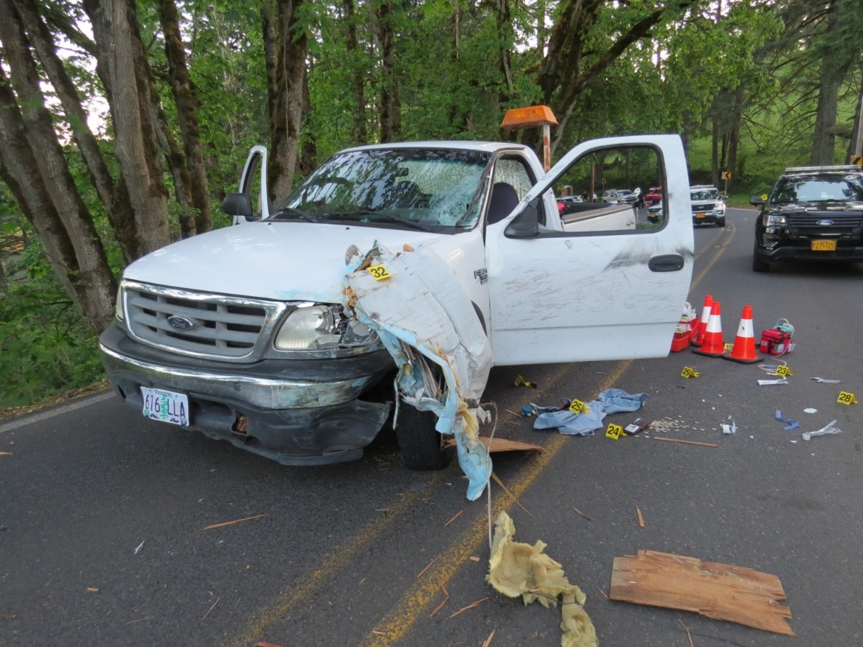
Peden’s truck with damage and debris from crashing moments prior into a truck and trailer.

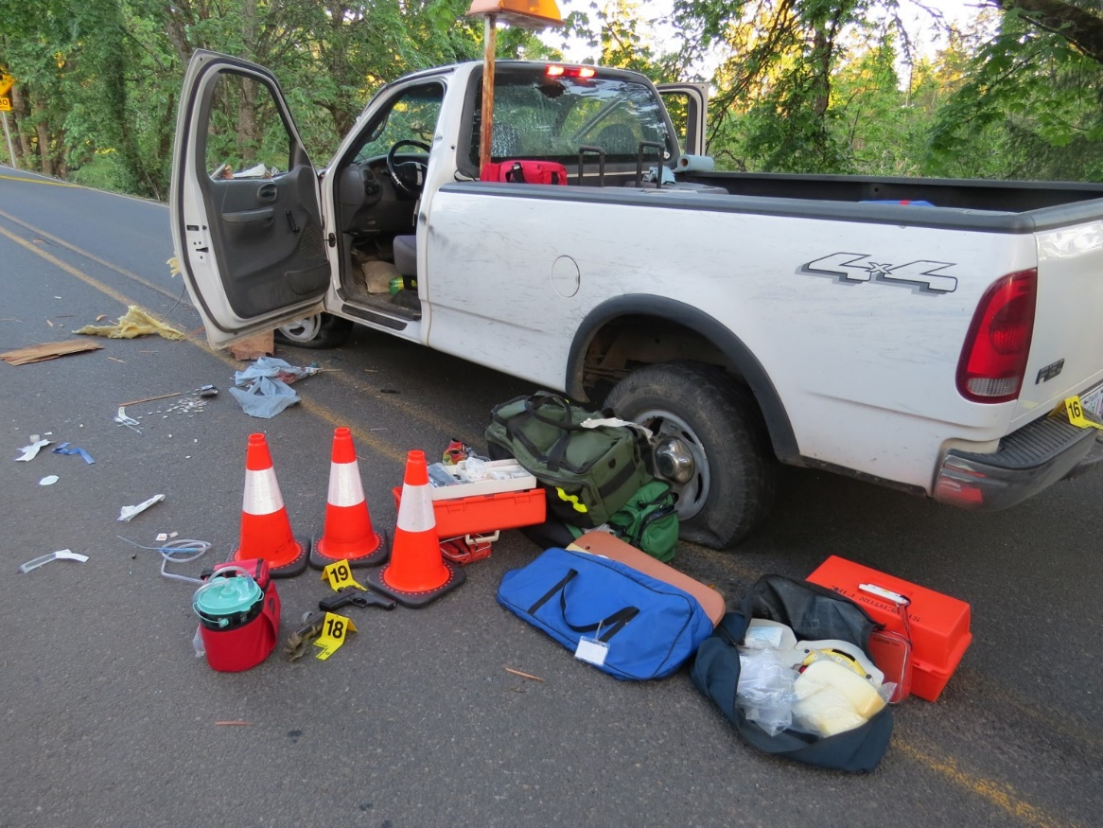
Peden’s truck and stolen handgun, surrounded by medical supplies used to treat Oliver.

Hereinafter referred to as Oliver, he/him/his. Molly Taylor identified as transgender and used the name Oliver. The Taylor family was consulted with and approved the use of the name Oliver for this press release.
Peden and Oliver had known each other through their church for years but had recently became friends.
Hereinafter referred to as Mrs. Taylor.
The truck is a white older model F150.
The handgun, a 9mm Jericho, belonged to Peden’s father and was taken without his knowledge or permission.
Reed suffered a single gunshot wound to the abdomen that was surgically repaired.
Senior Deputy Cereghino has been in law enforcement for 28 years, the first 4 years with the Independence Police Department and currently with the Marion County Sheriff’s Office. Cereghino is a veteran member of the Marion County Sheriff’s Office SWAT.
Sergeant Lamoreaux has been in law enforcement for 14 years, the first 7 years with the Mt. Angel Police Department and currently with the Silverton Police Department.
Officer Andersen has been in law enforcement for 1.5 years, the first year with the Washington County Sheriff’s Office and currently with the Silverton Police Department.
Sergeant Lamoreaux was the first police officer behind Peden followed by Officer Andersen and Senior Deputy Cereghino. Lamoreaux positioned his police vehicle a few feet behind Peden’s truck. Andersen positioned his police vehicle behind Lamoreaux. Cereghino positioned his police vehicle in the oncoming lane of travel next to Lamoreaux.
In total Cereghino (8), Lamoureux (1), and Andersen (2) discharged their service firearms 11 times toward Peden.
Officer Peter Finnegan of the Silverton Police Department positioned his police vehicle behind Cereghino. Officer Charles Carlin of the Silverton Police Department positioned his police vehicle behind Andersen. Both officers arrived as gunfire was being exchanged and did not return fire as Peden surrendered as they took safe positions outside of their vehicles. Both officers assisted in the detention of Peden and rendering of aid to Oliver.
After exchanging multiple rounds of gunfire with officers, Peden suddenly held both hands in the air and said he gave up. Peden was compliant when given commands to exit his truck and lay on the ground until officers safely approached and detained him in handcuffs.
An examination of all police vehicles on scene while Peden was shooting at officers revealed 4 vehicles were struck at total of 5 times by bullets fired by Peden. See attached photos.
As Senior Deputy Cereghino arrived on scene, he heard multiple gunshots being fired outside of Peden’s truck and then heard a distinct gunshot being fired inside the truck. The passenger side window had a single gunshot hole through it, coupled with a visible close contact single gunshot wound to Oliver’s face, was consistent with Peden sitting in the driver seat as he shot Oliver in the face at close range as Oliver sat in the passenger seat.

