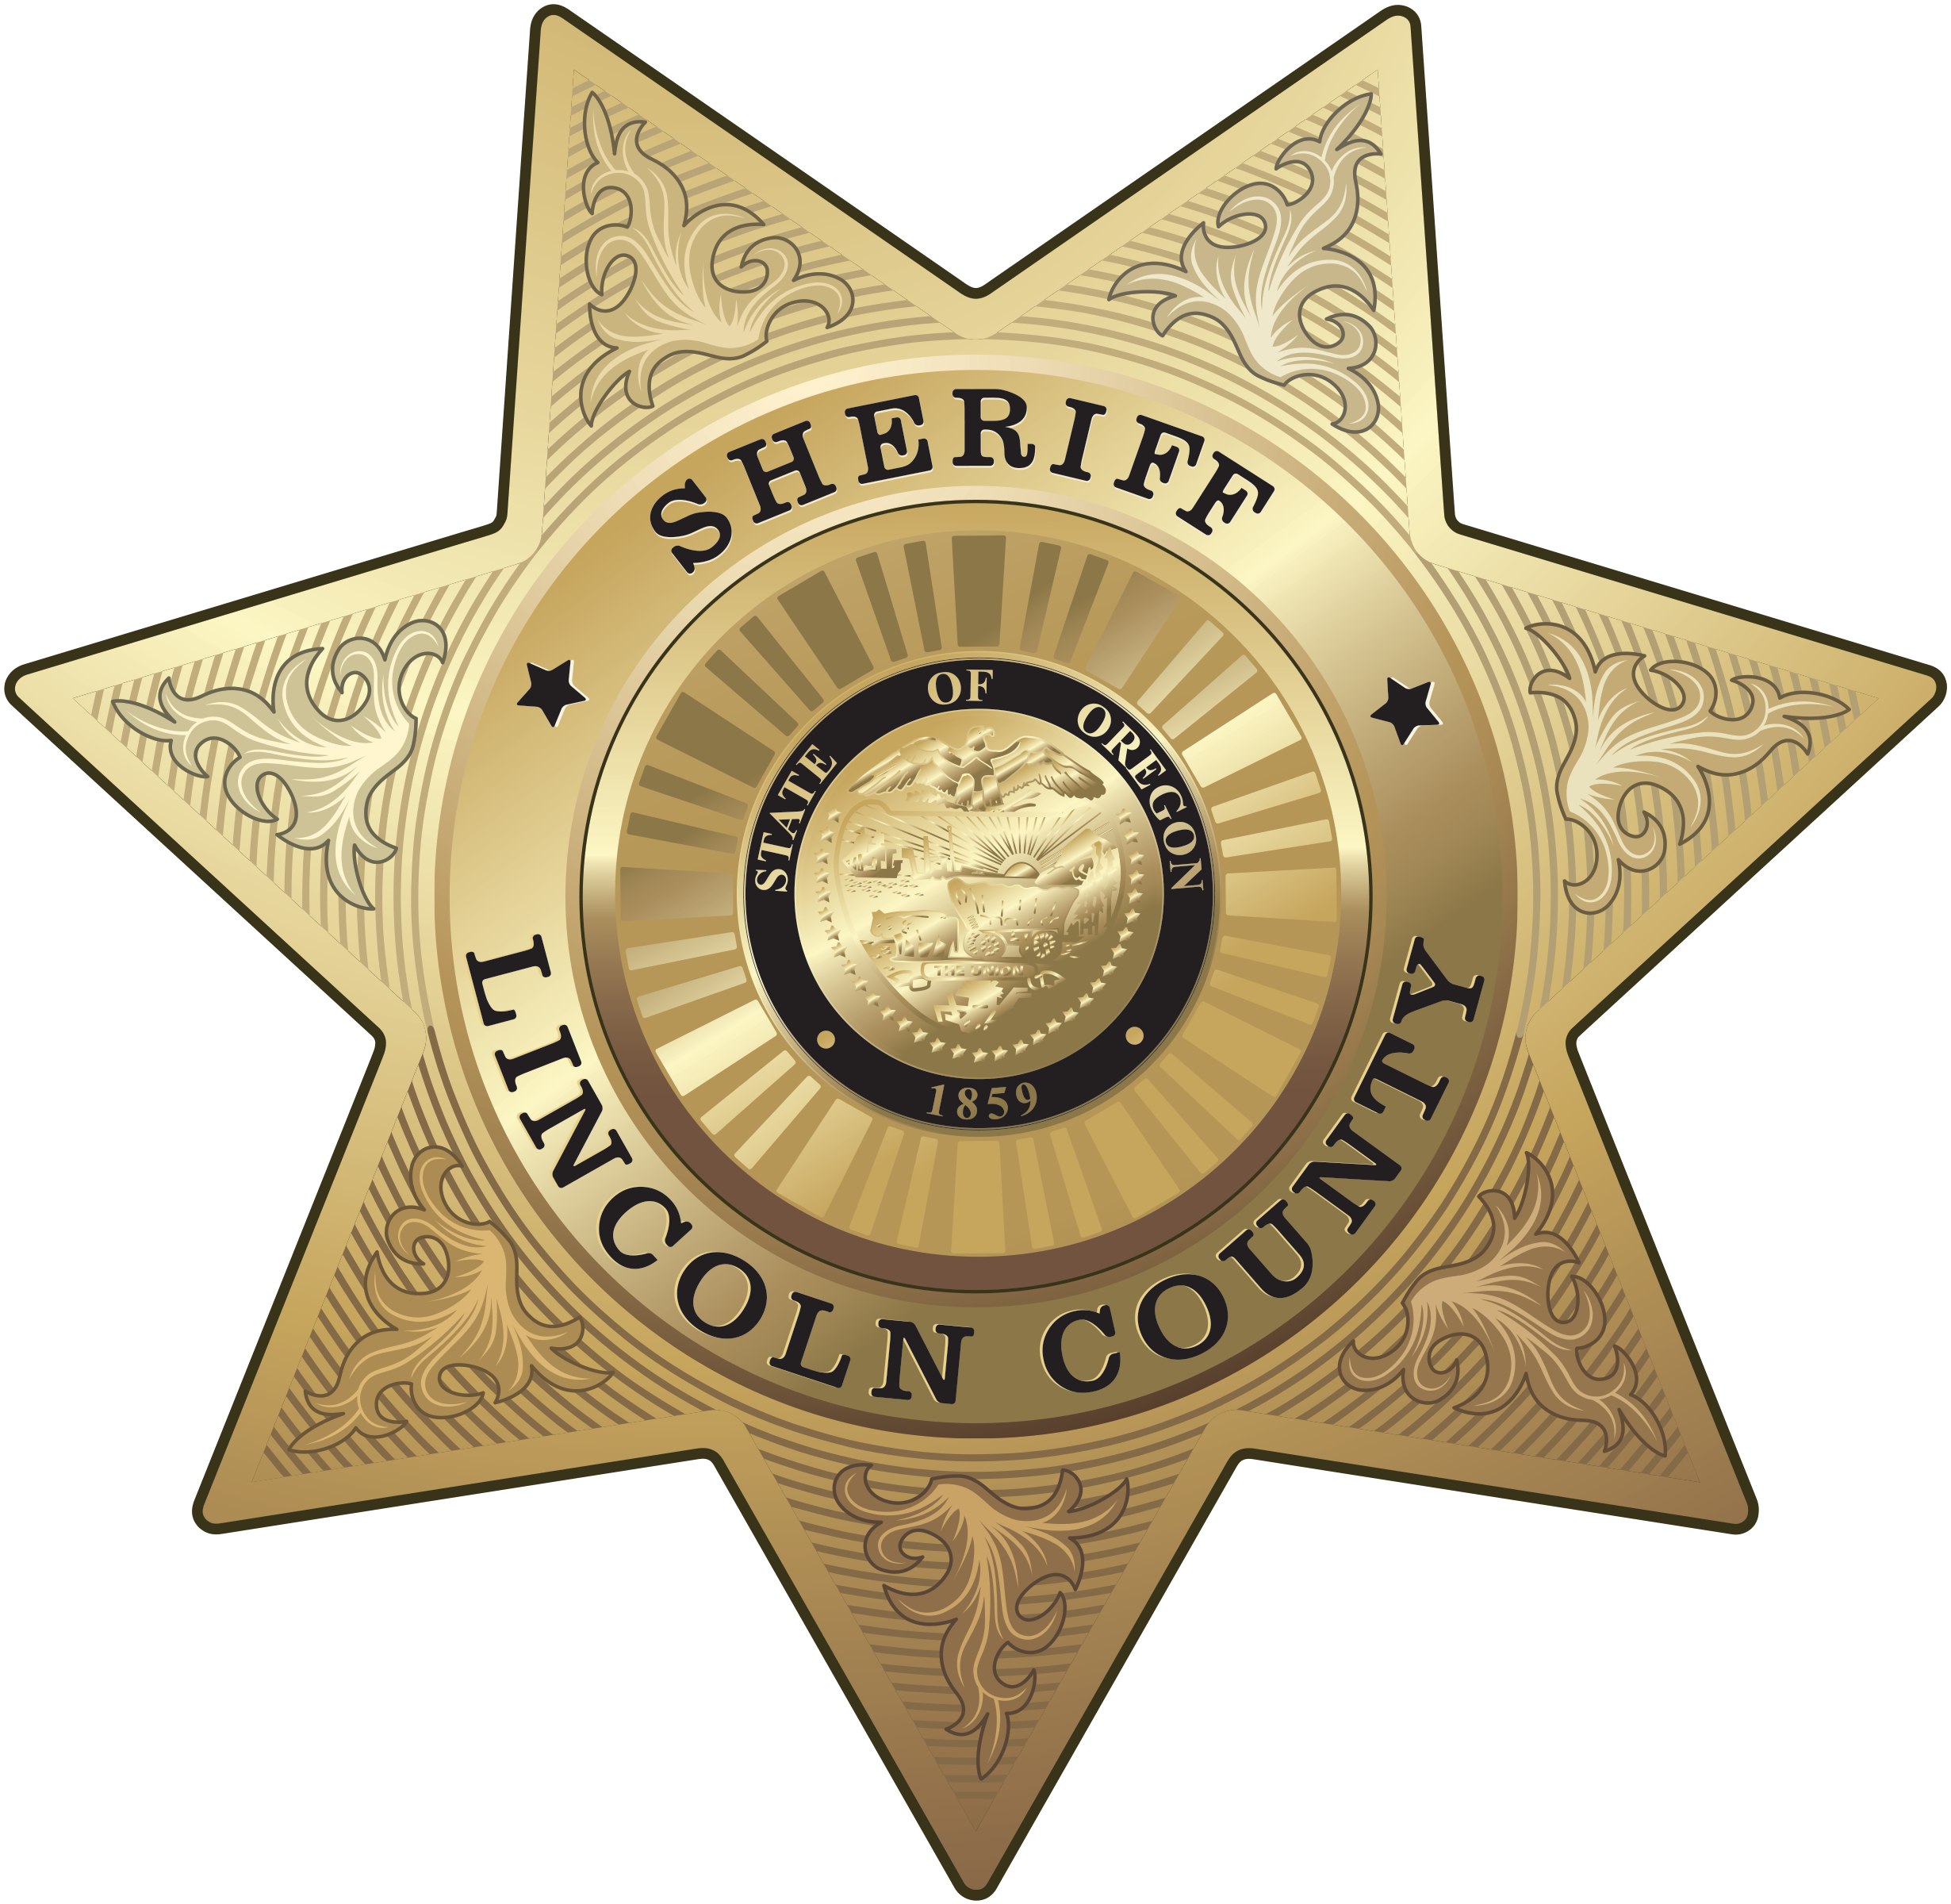
OFFICE OF THE SHERIFF

Sheriff Curtis L. Landers
225 W. Olive Street
Newport, Oregon 97365
(541) 265-4277
Fax (541) 265-4926

MEDIA RELEASE
FOR IMMEDIATE RELEASE

Date: December 1, 2021

Contact: Curtis L. Landers, Sheriff
541-265-0652
clanders@co.lincoln.or.us

NO SHAVE NOVEMBER

During the month of November Sheriff’s Office members participated in the No Shave November campaign. The No Shave November campaign is a month-long journey where participants forgo shaving and grooming to raise cancer awareness to educate about cancer prevention, save lives and aid those fighting the battle. For the Sheriff’s Office this is a big deal because the policy of the Lincoln County Sheriff’s Office does not allow beards for deputies in uniform.

The Sheriff’s Office chose to partner with and donate to our local Pacific Communities Health District Foundation in support of “Cancer care” or CAN Cancer”. We wanted to keep donations local, stated Sheriff Landers.

Sheriff Landers stated this is an exciting opportunity for our team members to engage in wearing a beard and donating to an excellent cause. This year we upped the challenge to our members and anyone who donated at least $50 could keep their bead through December until the end of the year.

Based on the quick success this achieved early in the month, Sheriff Landers offered another challenge to encourage more donations between patrol deputies and corrections deputies. Whichever team donates the most by the end of November will be allowed to keep their beard for an additional month.

Sheriff Landers didn’t want to leave anyone out of the activities so female deputies could color their hair in violation of policy. Same rules applied to females as males for how many months they could keep color in their hair.

At the end of the month, the Sheriff’s Office raised $13,475 toward the cause. Sheriff Landers stated he could not have imagined the teams donating over $13,000 and stated it is a true testament to the character, generosity, and gratitude of the Sheriff’s Office team. They are an amazing group of men and women, and this illustrates how much they support our local community and the efforts toward cancer education and treatment.

In the end, patrol won the competition with donations totaling $8,125, but everyone was a winner. Due to the huge success, Sheriff Landers extended the number of months so corrections deputies can wear their beards and color their hair until the end of January while patrol can go to the end of February.

Don’t be alarmed if you see some very hairy deputies out there in the next couple of months and remember it was for a great cause.

Sheriff Landers would like to thank the Samaritan Communities Health District Foundation and Dr. Leslie Ogden for their partnership and continued support to our community.

