Media Release – Attempt to Identify

Date: 05/24/22 Case Number: A22-760

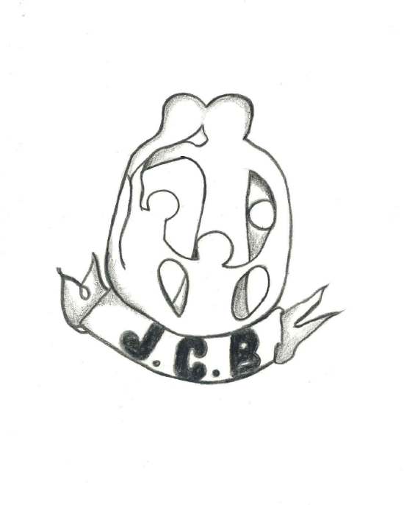
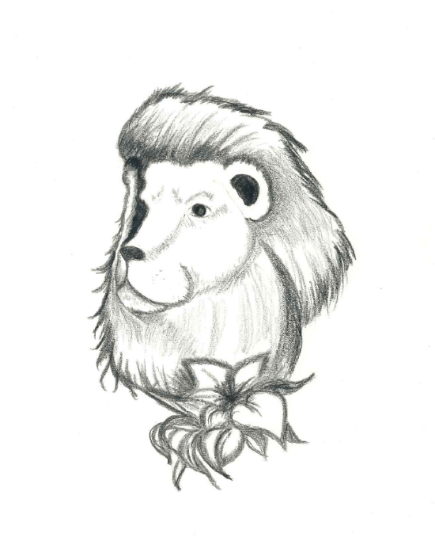
The Cowlitz County Sheriff’s Office is seeking the public’s help in identifying the remains of an adult female. In March of this year detectives recovered the body of an adult female in a local body of water. Traditional means of identifying the remains have so far been unsuccessful. Detectives commissioned the help of a local artist to recreate tattoos found on the body. We are asking for anyone who recognizes this combination of tattoos to please contact Detective Caity Neill at (360) 577-3092.

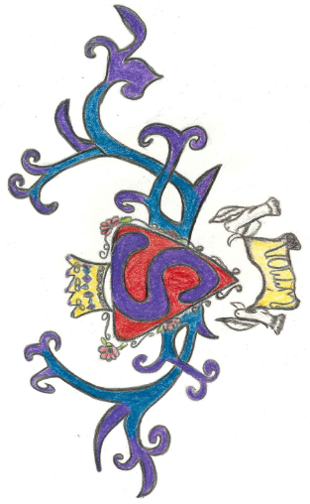

For those who wish to remain anonymous, information can be sent by using the following link: https://www.co.cowlitz.wa.us/FormCenter/Sheriffs-Office-26/Warrant-or-Suspicious-Activity-TIP-281

