Traffic Advisory
Portland Water Bureau
For Immediate Release
June 17, 2022

For more information, contact Public Information at 503-823-8064.

Water system improvements require detours for SE 19th Ave Neighborhood Greenway this summer

The traveling public is advised to plan ahead and choose an alternate route around construction taking place on SE 19th Avenue and SE Lambert Street in Sellwood this summer and fall. Sections of Southeast 19th Avenue will be closed starting in late June as a contractor working for the Water Bureau replaces more than 4,800 feet—just under a mile—of aging water main.

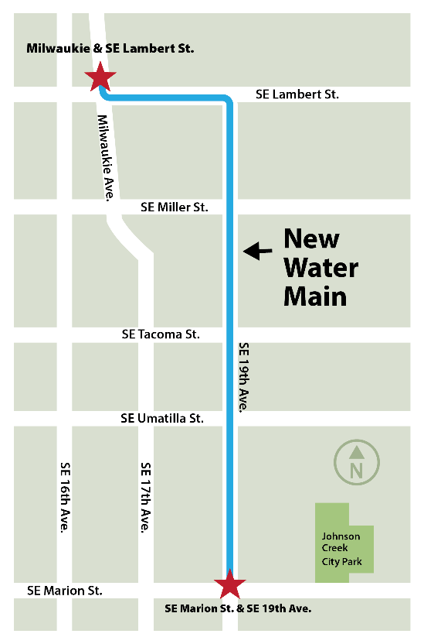
- Street closures: Streets will be closed during work hours, Monday through Friday between 7 a.m. and 6 p.m., and detours will be in place. For limited local access, please talk with a member of our crew before driving into a work zone. We want to keep you and your vehicle safe.

- Traffic detours on SE 19th Avenue: People walking, cycling, and driving will likely be detoured at least one block east or west. Plan to detour around the work zones. If you live in the work zone, plan for it to take extra time to get to and from your house.

“We want everyone to get home safely to the dinner table, the dog park, or the ball field. Much of the work is underground. Work zones around trenches protect those workers you may not see,” said Water Bureau Chief Engineer Jodie Inman. “We thank our neighbors for their patience while we do this crucial work in your neighborhood. It may seem inconvenient now, but we believe that the results of our investment in Sellwood’s water system will be worth it.”

The Water Bureau encourages people to keep their distance from crews at work and to slow down when traveling through work zones. Changes in traffic patterns combined with the presence of workers and the frequent movement of work vehicles could lead to crashes, injuries, and fatalities.
To protect yourself and city workers from death and injury, we ask Portlanders to follow these safety steps:
- Keep your distance. For the health and safety of everyone, please give our crews the space to complete their work while maintaining proper distance. City bureaus will send mailers or door hangers to homes and businesses in an area before major work.
- SLOW DOWN. Speed is a major factor in crashes. If you must drive, follow the work zone speed limit. Slow down, don’t tailgate.
- Use an alternate route. When you can, avoid streets with posted work zones.
- Obey all speed and warning signs. Work zone signs apply to everyone traveling through—whether the person is walking, biking, rolling, or driving.
- Be alert and look out for all road users. Put down your phone and pay attention to the road conditions ahead of you.
- Stay clear of construction vehicles. Heavy vehicles travel in and out of the work areas and can make sudden moves. We know it’s interesting to see our machines at work, but please keep a safe distance from the work zone if you plan to watch.
- Expect delays and be kind. Our goal is to get you through our work zone safely, while also completing our street improvements in an efficient manner. We appreciate your understanding.

Project improvements
The existing main was installed in 1927 and has had six breaks in the last 10 years. This new ductile iron pipe will make Sellwood’s water service more reliable, reducing the likelihood of breaks in the future, and is expected to last at least another 100 years. The project also improves neighborhood fire protection. Six new fire hydrants will improve firefighters’ access to water and help the bureau continue to meet state fire codes. Several new ADA accessible crossings will also be installed as part of this project. To learn more about the project and sign up for project updates, visit portland.gov/water/Lambert19.

Water Bureau contractors plan to take this project on five blocks at a time. The affected areas are:
- Southeast 19th Avenue from Southeast Marion Street to Southeast Lambert Street
- Southeast Lambert Street from Southeast 19th to Southeast Milwaukie Avenue

About the Portland Water Bureau
The Portland Water Bureau serves water to almost a million people in the Portland area. Portland’s water system includes two great water sources, 53 tanks and reservoirs, and 2,200 miles of pipes. With 600 employees working on everything from water treatment to customer service, the Water Bureau is committed to serving excellent water every minute of every day.

