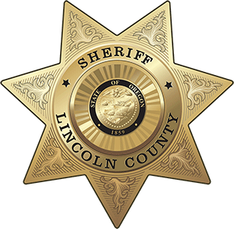
OFFICE OF THE SHERIFF

Sheriff Curtis L. Landers
225 W. Olive Street
Newport, Oregon 97365
(541) 265-4277
Fax (541) 265-4926

MEDIA RELEASE
FOR IMMEDIATE RELEASE

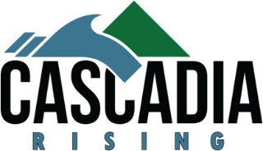
Date: June 6, 2022

Contact: Virginia “Jenny” Demaris, Emergency Manager
(541) 265-4199
vdemaris@co.lincoln.or.us
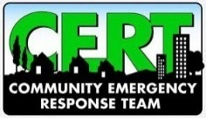
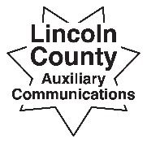
CERT and ACS Teams to Conduct Communications Drill as Part of Cascadia Rising Exercise

(06.06.22 – Lincoln County Sheriff’s Office on behalf of local CERT Chapters)

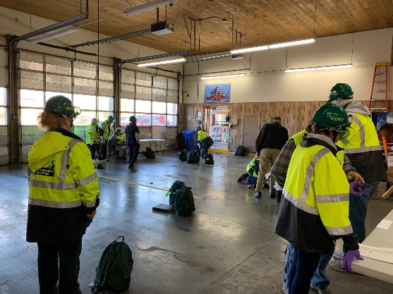
On Saturday, June 11, 2022, from 9:00 am to 11:00 am, local Community Emergency Response Team (CERT) and Auxiliary Communications Service (ACS) members will be supporting the 2022 Cascadia Rising exercise (CR22) by conducting a communications and simulated damage assessment drill.

CERT and ACS members will be in various neighborhoods across the county, practicing skills needed to conduct neighborhood damage assessments and then relaying the information to area command hubs. CERT members will collect the simulated damage assessment information, summarize, then relay to members of the Lincoln County Sheriff’s Office ACS team. The ACS Team Members will then forward the information via amateur radio to the County Emergency Operations Center mobile communication center.

The CERT Members and ACS Members will utilize several forms of communication during the exercise and may hear terms such as “this is a practice drill for local area CERT Chapters” on these frequencies. Information relayed during the drill will include deteriorating road conditions, infrastructure failures, fires, and civil unrest. A reminder for anyone that may be listening on their own amateur radio or scanner - the information reported during this drill is all simulated. Communication that will be utilized include FRS, GMSR and Amateur Radio:

- FRS – Family Radio Service The Family Radio Service (FRS) is a private, two-way, short-distance voice communications service for facilitating family and group activities. The most common use for FRS channels is using small hand-held radios that are similar to walkie-talkies.
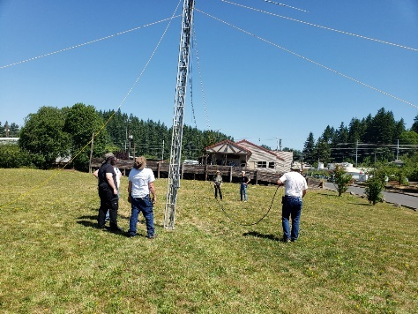
- GMRS – General Mobile Radio Service - The General Mobile Radio Service (GMRS) is a licensed radio service for short-distance, two-way voice communications using hand-held radios, mobile radios and repeater systems. In 2017, the FCC expanded GMRS to also allow short data messaging applications including text messaging and GPS location information.
- Amateur Radio Service (HAM) – The Amateur Radio Service is made up millions of amateur operators in all areas of the world who communicate with each other directly or through ad hoc relay systems and amateur-satellites. They exchange messages by voice, teleprinting, telegraphy, facsimile, and television. In areas where the FCC regulates the services, an amateur operator must have an FCC or Canadian license. FCC-issued Reciprocal Permit for Alien Amateur Licensee are no longer needed.

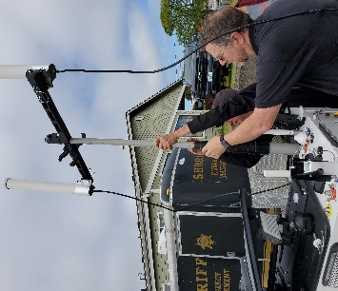
The local area CERT Chapters have approximately 169 active volunteers between the 4 Chapters and ACS has approximately 70 active volunteers.

Points of Contact for Local CERT Chapters of Lincoln County
Volunteer Group | Contact Name | Contact Email
Depoe Bay CERT (Depoe Bay Fire District) | Sherry Beard | depoebaycert@gmail.com  615-426-4572
North Lincoln CERT (North Lincoln Fire District) | Raul Grimes, CERT PIO | publicinformationofficer@northlincolncountycert.org  541-992-2878
Central Coast CERT (Newport/Newport Fire District) | Mike Eastman, CERT Volunteer Coordinator | c2cert@gmail.com  541-270-4114
South Lincoln County CERT (Seal Rock, Waldport, Yachats) | Lynda Engle, CERT Volunteer Coordinator | slcocert@gmail.com  541-921-4008
Auxiliary Communications Service (Sheriffs’ Office – EM Division) | Jenny Demaris, Co. Emergency Manager | vdemaris@co.lincoln.or.us  541-265-4199
Interested in becoming a CERT or ACS volunteer? Learn more about the Lincoln County Public Safety volunteer groups and how you can serve your community.

###
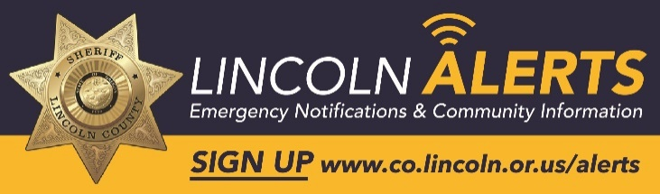
Respectfully submitted,

Virginia "Jenny" Demaris
Lincoln County Sheriff's Office
Emergency Management Division
Office Phone: 541-265-4199
Lincoln County Call Center: 541-265-0621
Email: vdemaris@co.lincoln.or.us
Website: https://www.co.lincoln.or.us/emergencymanagement
Facebook: https://www.facebook.com/lcemergencymanagement
Lincoln Alerts – Emergency Notifications: www.co.lincoln.or.us/alerts
Media Releases - https://www.flashalert.net/id/LCSO
Language Translation Options:
- Lincoln Alerts Messages - Member Portal - go to the top right-hand corner for translation options.
- Sheriff’s Office Media Releases via Flash Alert – website translation at the very upper right-hand corner.
- Lincoln County Website – website translation at the very bottom right-hand corner

