SEEKING INFORMATION
Death Investigation

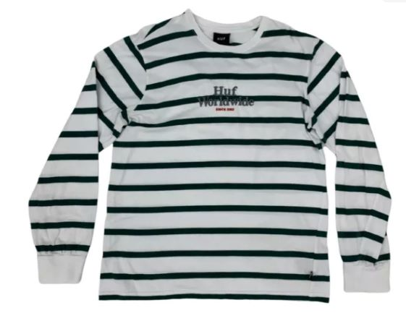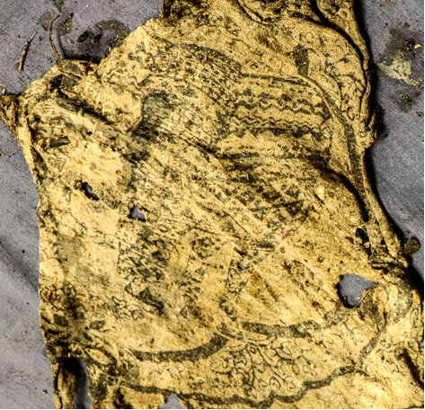

HUF shirt with the sleeves removed Elephant Print Shirt
(White with green stripes)

Age at Disappearance: 30-50
Sex: Female
Hair: Dark
Height: 5’00” to 5’ 08”

Located on West Boundary Road near Lowell, OR

LANE COUNTY SHERIFF’S OFFICE
541-682-4150 opt. 1
Reference Case #22-2856

