Media Release
Portland Water Bureau
For Immediate Release
August 4, 2022

For more information, contact Public Information at 503-823-8064.

  - Work on Sellwood Water System Impacts Southeast Tacoma Street in August

PORTLAND, OR --- Portland Water Bureau contractors are temporarily closing one lane of traffic on SE Tacoma Street at SE 19th Avenue on weekdays from 9 a.m. to 3 p.m. for up to a week starting August 9, 2022. There will be additional closures at this intersection throughout the summer and fall.

SE Tacoma is a primary route for drivers traveling though the Sellwood neighborhood to access McLoughlin Blvd./Oregon 99E and the Sellwood Bridge. Drivers hoping to access the west side may consider using the Ross Island Bridge as an alternate route to and from McLoughlin/99E.

The lane closures will allow crews to replace an aging water main (pipe), improving water quality and reliability in Sellwood. Impacts to sidewalks, bicycle routes and vehicle routes will change during the various phases of work on this project. The traveling public should stay alert and follow instructions from signage and flaggers.

Traffic impacts
- Southeast Tacoma Street: Traffic will be limited to one lane. Some parking will be removed for the duration of construction to make room for work to take place.
- Southeast 19th Avenue between Southeast Tenino and Southeast Spokane: Traffic will be detoured one block east or west at Southeast Tenino and Southeast Spokane Streets.
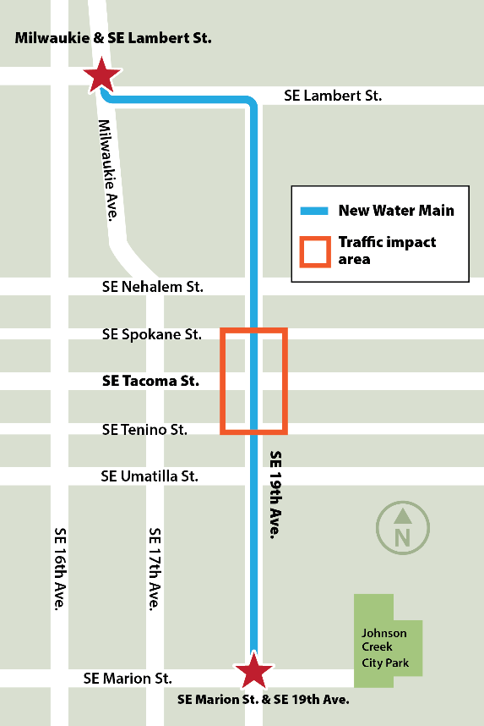
- Sidewalk access: Sidewalks on Southeast 19th Avenue will remain open. People traveling along Southeast Tacoma Street will be detoured to the opposite side of the intersection from where construction is taking place at Southeast 19th Avenue.
- Bicycle access: This work will impact bicycle travel on the Southeast 19th Avenue Greenway. In some cases, people cycling on SE 19th Avenue will be detoured one block east or west. Other times, cyclists will be diverted onto the sidewalk. Reader board displays and signage will direct people to the safest route.
- TriMet: No bus line stops will be impacted, but travelers should plan for delays.

What to expect
- Please allow extra travel time and respect work zone safety cones, detours, and flaggers.

- No homes or businesses are expected to be out of water service because of this work.

- The traveling public is reminded to stay alert and use caution as traffic may suddenly slow or stop. To avoid traffic delays, motorists are encouraged to use alternate routes around the work site.

About the SE 19th and Lambert Water Main Replacement Project
As part of our ongoing investment in southeast Portland’s water supply, the Water Bureau is replacing 4,800 feet—just under a mile—of an aging water main (pipe) along SE Lambert Street and SE 19th Avenue. The existing main was installed in 1927 and has had six breaks over the past decade. The new pipe will reduce the frequency of breaks and improve water quality. Learn more and sign up for project updates: portland.gov/water/lambert19.

About the Portland Water Bureau
Portland’s water system includes two great water sources, 53 tanks and reservoirs, and 2,200 miles of pipes. With 600 employees working on everything from water treatment to customer service, the Water Bureau is committed to serving excellent water every minute of every day.

