MEDIA RELEASE
For more information, contact Public Information at 503-823-8064.

For Immediate Release
Jan. 31, 2023

Willamette River Crossing Paused to Adjust for Multiple Regional Infrastructure Projects

Timing has changed for implementation of the final phases of design and construction for the Willamette River Crossing project.

“The Willamette River Crossing is a critical project necessary for providing water to the west side of the Willamette River following a Cascadia Subduction Zone earthquake. We know we have the right technology and the right approach to build this critical crossing, but this is not the right moment,” said Water Bureau Chief Engineer Jodie Inman. “Making thoughtful, well-examined decisions about how to use ratepayer dollars is a Water Bureau value.”

A media availability with Water Bureau Chief Engineer Jodie Inman and Water Bureau Director Gabriel Solmer will be held at 1 p.m. Tuesday, Jan. 31.

Zoom: us02web.zoom.us/j/83555861633

Reasons for the change
- Construction overlap with other regional projects, including the Portland Water Bureau’s Bull Run Treatment projects
- Inflation projections
- Supply chain challenges
- City and bureau values of affordability and financial stewardship to ratepayers

“Willamette River Crossing remains a priority project for me and the Portland Water Bureau but we face serious competition for construction resources. A delay in construction will allow us to adapt while responding to community concerns about development in the RiverPlace neighborhood,” said Water Commissioner Mingus Mapps.
The Willamette River Crossing project is currently in the final stages of design and was on track for an update to Portland City Council this spring and entering the construction phase later this year. During the last year, a project team, including nationally and regionally recognized tunneling experts, determined that a different technology and a minor change to alignment was needed. Businesses and neighbors affected by this project were informed about the changes through open houses and other outreach efforts.

In line with the Water Bureau’s commitment to the values of affordability, risk reduction and community impact and our mission to provide safe drinking water every minute of every day, the Water Bureau performed a final check before moving forward with construction. In the last 45 days alone, new information on construction inflation projections, supply chain challenges and overlap with other Water Bureau, City of Portland and regional projects of a similar nature intensified the potential risks with moving forward now.

“It is disappointing to not have this critical crossing online in the next couple of years, but the decision is the right one to support the Water Bureau’s and the City’s values of affordability, smart decision-making and adaptability. I look forward to drinking water from this crossing in the future.” said Inman.

The Water Bureau is in the process of revising the schedule for the Willamette River Crossing. Tentative next steps include:

- Addressing current contracts.
- Closing down construction sites.
- Implementing a plan to complete the design.
- Outreach to maximize opportunities for Certification Office for Business Inclusion and Diversity (COBID) and equity contractors prior to re-bidding the work.
- Re-bidding the project.
- Construction starting in fiscal year 2027–28.

Purpose of the Project
The pipes that carry water from the east to west side of the Willamette River are more than 50 years old and will likely not survive a major earthquake. To help us keep water flowing to the west side, the Portland Water Bureau has been planning to install an earthquake-resilient pipe deep under the river, a project we call the Willamette River Crossing.

Project History
In 2010, a Water Bureau report recommended an earthquake-hardened river crossing. More studies in 2019 explored the best path the pipe should take across the river, how it should be installed and how to connect it to the existing system.

Exploratory Phase
The bureau anticipated that this work would be challenging, so an exploratory phase was folded into the project. This allowed the bureau to spend a little and learn before spending a lot. The bureau needed to know exactly what was underground before going “full bore,” so geotechnical experts probed a small-scale pilot bore in August 2020.

The pilot bore uncovered problems. The Horizontal Directional Drilling (HDD) technology from the original plan required the hole to stay open after drilling so the pipe could be threaded through later. Instead, the hole collapsed and filled with gravelly soil. The geoprobe contractor, one of the most respected and capable in the nation, advised that HDD was not viable.

Based on data from the geoprobe and additional soil probing and sampling, the bureau changed the tunneling method and the path of the pipe to better address risk. These changes will be incorporated into the final design and will be used as the project moves into the construction phase in the future.

ABOUT THE PORTLAND WATER BUREAU
The Portland Water Bureau serves water to almost a million people in the Portland area. Portland’s water system includes two great water sources, 53 tanks and reservoirs, and 2,200 miles of pipes. With 600 employees working on everything from water treatment to customer service, the Water Bureau is committed to serving excellent water every minute of every day.

Frequently Asked Questions:

How much has already been spent and how much of that investment can be recovered?
The Water Bureau has spent $38 million on this project during the last 10 years. When the construction phase resumes in fiscal year 2027–28, it will build upon prior work and expenses.

Which contracts does this affect and how will they be resolved?
The JW Fowler (design builder) and MJA (owner’s representative) contracts will likely be closed. New contracts will be procured as we move toward completing the design and beginning construction. The bureau has appreciated the partnership and innovation of these two contractors throughout this complex project. They worked alongside bureau staff to adapt and develop a strong project plan and we continue to partner with them on Water Bureau projects.

How have you kept the community informed?
Authentic engagement with neighbors, area businesses and members of the broader community have been a priority for the bureau since the project's inception. We began a robust public engagement process in 2017 and will continue to listen, inform and adapt based on community needs.

In 2020–21, when the project’s exploratory phase revealed a need to change the project alignment and construction method, outreach staff significantly increased the level of public outreach on the project. Outreach staff informed additional stakeholders who were not previously affected by the project and employed additional strategies to reach people, including direct emails, phone calls, site visits, mailings and signage.

Water Bureau staff presented to the Downtown Neighborhood Association (DNA) regularly in 2022, providing project updates and opportunities for community members to ask questions and share concerns. In July, the bureau presented to the DNA and the RiverPlace Planned Community Association to share project updates and the latest project designs. In March 2022, our public involvement contractor, JLA, surveyed businesses expected to be affected by construction to learn their concerns and gain insights into how to minimize impact to local businesses.

The outreach staff assertively pursued opportunities to consult with potentially impacted businesses and residents. They contacted businesses in the area to set up one-on-one stakeholder interviews regarding business access needs. They sent mailings and e-newsletters to attract participation in an online open house with video and ASL translation to share project information and gather input on construction concerns. The team attended and presented at three well-attended DNA land use meetings and worked with neighborhood leadership to coordinate and host a group feedback session for nearby businesses.

The team regularly communicates with neighborhood leaders about questions and concerns they are hearing from neighbors.

E-newsletters can be found here: portland.gov/water/improvements/willamette-river-crossing/news. We will continue to provide updates as they become available through e-news and on the project website.

Where are the affected construction sites?
The most significant impacts are in Block J, which is the lot between SW Naito Parkway and Harbor Drive, south of Market Street, near where the off-ramp from I-405 North connects to Naito Parkway. Block J will be returned to its previous condition in the near future.

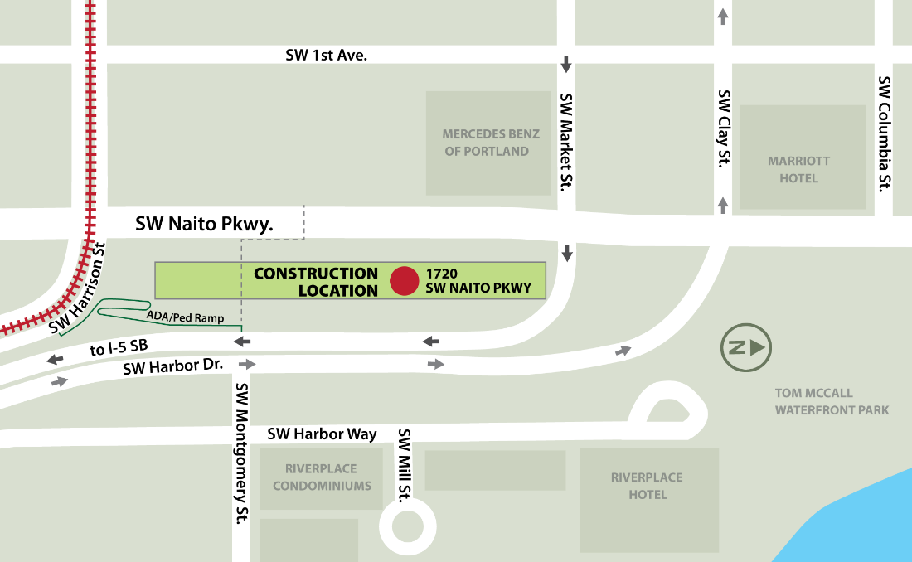

What if the earthquake happens tomorrow?
In the worst case scenario for a Cascadia Subduction Zone earthquake, it is quite likely that all river crossings will be damaged and may not be operable. This would result in limited to no water to the west side of the river for six to 12 months. While we are changing the schedule for the Willamette River Crossing, installing this crossing as soon as possible remains a very high priority for the Water Bureau.

Besides the Willamette River Crossing, what other measures are you taking to prepare for a major earthquakes and other disasters?
The Portland Water Bureau has centered planning for emergencies and climate change in all of its projects over the last several decades, including the new seismically reinforced Washington Park reservoir, and hardening the backbone of our system (a backbone system consists of key supply, treatment, transmission, distribution and collection elements). The new Bull Run filtration facility will make our water system more resilient to natural and human-caused disasters. Portland's groundwater system is also an important tool for system resilience and climate change. It improves the reliability of our water system by providing a robust secondary drinking water source that supplements the water we get from Bull Run.

We all have a role to play in preparing for disasters like earthquakes. Learn more about how to store water for an emergency, here: regionalh2o.org/emergency-preparedness. Sign up for PublicAlerts to receive emergency messages here: publicalerts.org.

When was the decision made to change the schedule?
The decision to change the schedule was made over the last two weeks after consultation with bureau and city subject matter experts and our Commissioner. The Water Bureau had been moving toward a construction start of later this year. However, the last two months brought about significant new information and changes regarding construction inflation, supply chain, competing projects, and City priorities. Changing the schedule for WRX provided the best option to ensure success of WRX as well as other high priority projects.

What’s the new timeline?
The project will be paused for approximately a year, after which time we will complete the design and re-engage with the contracting community and the public about construction of the crossing. On this tentative schedule, construction would start in fiscal year 2027–28.

How do you expect costs to change when construction resumes in fiscal year (FY) 2027–28?
It is possible that costs will increase by FY 2027–28, but several factors, along with continuous advancements in technology, make it difficult to predict future costs. There is also no guarantee that the project cost will increase. We are likely to see continued inflation, but its impact could be reduced if the rate of inflation slows. Technology may become less expensive and supply chain issues may resolve, which could affect costs on the Willamette River Crossing and other Water Bureau projects in the Capital Improvement Plan.

Will this change in schedule impact rates?
We do not expect this delay to change the rate forecast as it is still balanced across 10 years. For now, we have only changed the project schedule, not the scope, technology, location or other factors that affect cost. As we complete the design, new estimates for the work will be reflected in our capital plan. A benefit of the schedule change is increased flexibility in our Capital Improvement Plan in the next five to 10 years to address potential cost increases without impacting rates. More information about rates can be found here: portland.gov/water/pay-your-utility-bill/water-bill-rates-and-charges#toc-water-and-sewer-rate-ordinance-fiscal-year-2022-2023

Will the Portland Water Bureau continue to pursue easements for the alignment?
Open spaces near the river are rare and current developments are making them even rarer. The Water Bureau will continue to pursue easements during the pause to ensure the project’s viability.

What new technology will you use?
The current plan is to use microtunneling technology. Extensive exploration, design and modeling have shown that this technology currently offers the best balance of risks and costs. In the future, we may see new technologies that can do more and go farther at a lower cost. Our approach as we finalize the design will be to reflect on any changes in the industry or other new opportunities that may benefit the project.

What’s the new location?
We do not anticipate a change to the alignment. The current location remains the most feasible, least costly and lowest risk.

What will be different when the project resumes?
The approach is not expected to change.

Is it unusual for a project to change during the design phase?
Nearly all projects change in some way during the design phase, and project plans include contingencies within a schedule and budget to account for some change. This project and the project team have responded and adapted to significant factors that have impacted the project beyond what could have been reasonably anticipated. Some of those factors include new information about the soil from the geoprobe test, supply issues and disruptions related to the pandemic. This delay decision reflects the Water Bureau’s commitment to continuously evaluating the work in our portfolio and delivering the Capital Improvement Plan with the least risk and most cost effectiveness.

Is this project delayed because of the filtration project?
This project is being delayed because it is the best plan to ensure delivery of the Water Bureau’s Capital Improvement Plan while meeting federal requirements, including delivery of the Bull Run Treatment projects by the compliance deadline. The convergence of the treatment projects and the Willamette River Crossing project is one factor in the delay.

Will the schedule change impact the OMSI District master plan?
The Water Bureau is actively engaging and partnering with OMSI on plans that support the OMSI District development while allowing the future construction of the Willamette River Crossing.

