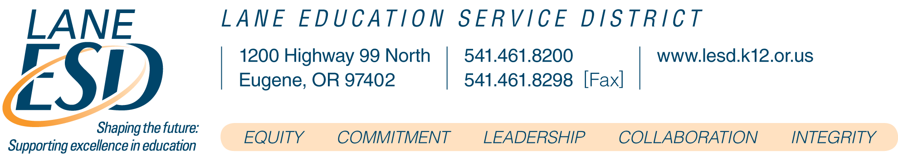

PRESS RELEASE

FOR IMMEDIATE RELEASE

Celebrating and Ribbon Cutting Ceremony for New Migrant Education Program Space at Lane Education Service District

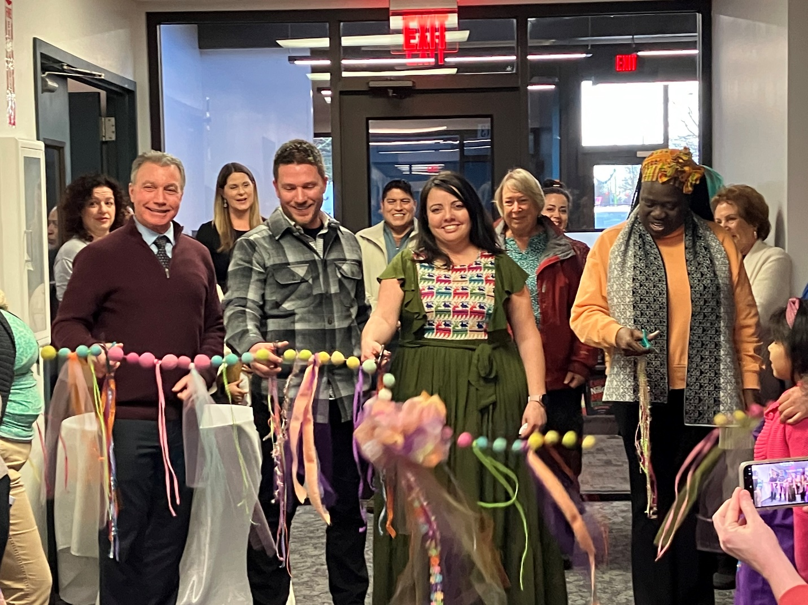

Eugene, Oregon - March 8, 2023 - Lane County Educational Service District: Families, community partners, staff, and Lane ESD's Board of Directors gathered last night to celebrate the revisioning and remodeling of the Migrant Education Program space at Lane ESD's Main Campus in Eugene. The remodeling's goal was to create an accessible and welcoming space for local families utilizing the Migrant Education Program, whose mission is to support local families. The celebration included a grand opening celebration, ribbon cutting, and tours of the new space.
The new space is spacious and offers endless possibilities for supporting collaborative work, including hosting conferences for both smaller and larger groups with space carved out for business functions with connectivity for video conferencing.

The official ribbon-cutting participants included School Board Chair Linda Hamilton, Superintendent Tony Scurto, Migrant Education Program Administrator Ana Quintero-Arias, and Facility Manager Brad Johnston.

Migrant Education Program (MEP) provides supplemental educational services to migrant students to support their academic success throughout the year from Preschool-12th Grade. Through their advocacy work and collaboration with local school districts and community partners, MEP can help inform families about their rights and highlight services available to them in the community, with helps to strengthen families with tools to navigate the educational system effectively and proactively.

For more information, CONTACT
Superintendents Office
Julie Simmonds, Executive Assistant to Superintendent
Lane Education Service District |1200 State Hwy 99 N | Eugene, Oregon 97402
p: 1-541-461-8213

