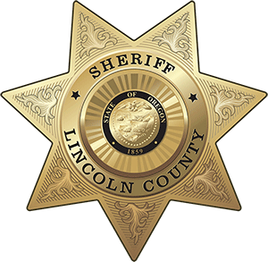
OFFICE OF THE SHERIFF

Sheriff Curtis L. Landers
225 W. Olive Street
Newport, Oregon 97365
(541) 265-4277
Fax (541) 265-4926

TIP OF THE WEEK
FOR IMMEDIATE RELEASE

Date: March 28, 2024

Contact: Sheriff Curtis Landers
541-265-0652
lcsheriff@co.lincoln.or.us

DISTRACTED DRIVING

The National Highway Traffic Safety Administration (NHTSA) has declared April as Distracted Driving Awareness Month. Distracted driving is any activity that takes the driver’s attention away from driving. Cell phone use including texting, talking on the phone, or using social media are some of the activities that are the most dangerous. This is because cell phone use takes your visual, manual, cognitive, and auditory attention away from driving.

While cell phones are some of the most dangerous distractions, other activities such as eating, talking with passengers, grooming, and reading can be dangerous and deadly. According to the NHTSA, 3,522 people were killed by distracted driving in 2021. You can learn more about the dangers of distracted driving by visiting the National Highway Traffic Safety Administration’s “April is Distracted Driving Awareness Month” webpage.

Use these tips to help keep your car distraction free:

- Don’t call or text while driving. Instead, pull over in a safe place to read and send texts or make a phone call.
- Establish a “co-pilot” passenger to manage your cell phone, GPS, and other distractions.
- Look up your destination ahead of time and become familiar with the area. This will help prevent the need to look at GPS while driving.
- Enjoy your meal at home, in the restaurant, or while parked safely. Eating while driving increases your risk of traffic collisions and the likelihood of choking.
- Keep pets crated or otherwise secured for safety. This will help keep your furry friend safer in the event of a crash and prevents them from crawling onto your lap or other distracting activities.
- Recruit the whole family for distraction-free driving. Teach your children the importance of keeping your attention on the road even before they can drive.
- If your children need help, pull over to help address their needs instead of reaching to the backseat while driving.
- Encourage friends and family to drive distraction-free. By speaking up, you may save their life and others on the road.

For more information and tips visit our website at www.lincolncountysheriff.net and like us on Facebook at Lincoln County Sheriff’s Office – Oregon.

###

