Empowered Together AI Photo Booth Celebrates 25th Anniversary of Boys & Girls Clubs of Southwest Washington
As the Boys & Girls Clubs of Southwest Washington (BGCSW) celebrates its 25th anniversary, a very unique addition promises to capture the strengths of the community like never before. Introducing the #EmpoweredTogether AI Photo Booth, designed to highlight the “superpowers” of our local community while supporting BGCSW’s mission of empowering youth to reach their full potential.
“For the 25th Anniversary of Boys & Girls Club of Southwest Washington, we sought to create an experience that showed youth their true strengths, potential and a look at the vibrancy they bring into their community. For this monumental moment, we wanted to standout and transcend what’s been done before. Thus, the AI Photo Booth was created. As individuals step forward to identify their top three strengths, our AI seamlessly transforms these qualities into vibrant, sky-blue city portraits presented in a captivating trading card format. Each card not only celebrates the unique essence of its bearer but also symbolizes the collective power and resilience of our community when united.” said the project and production team at For Good & Co.
To continue to foster building relationships and connection, at the end of the experience the booth sends each guest a digital copy of their card to share through social media, and prints two copies of their trading card so they can trade with their friends.
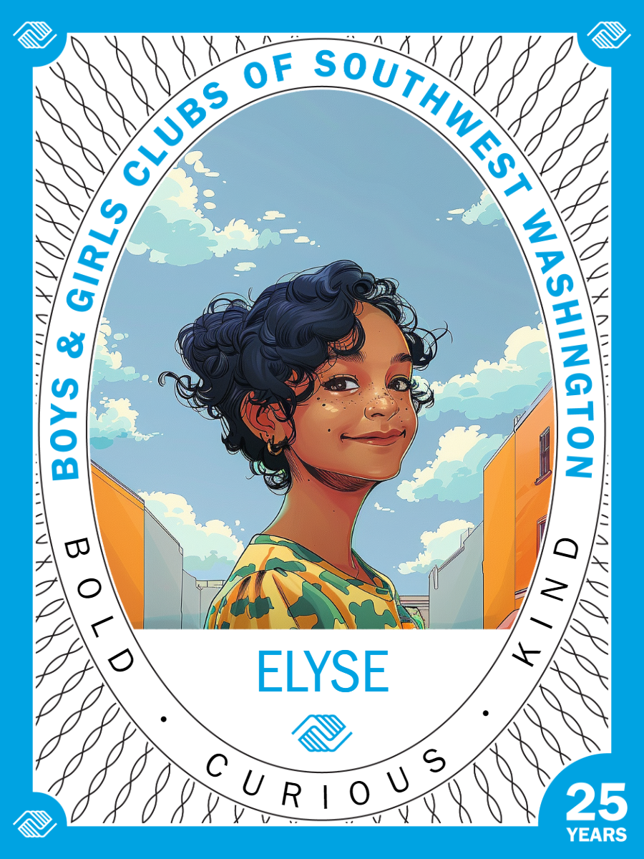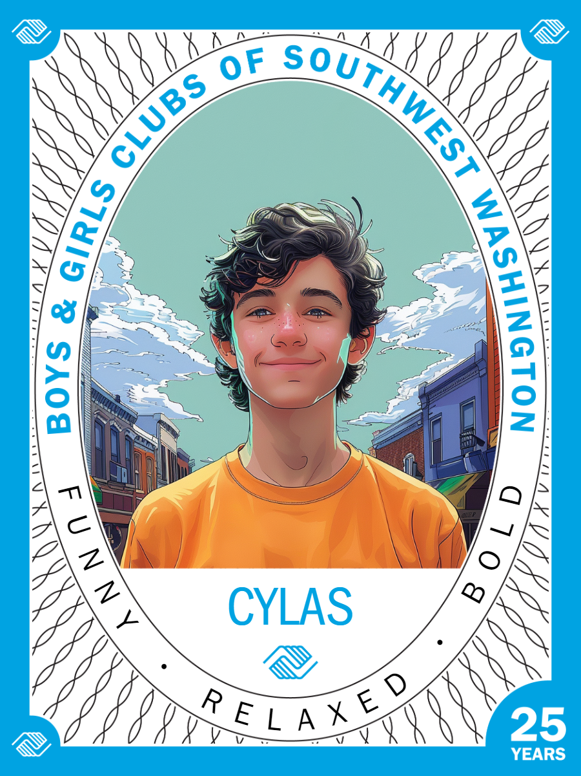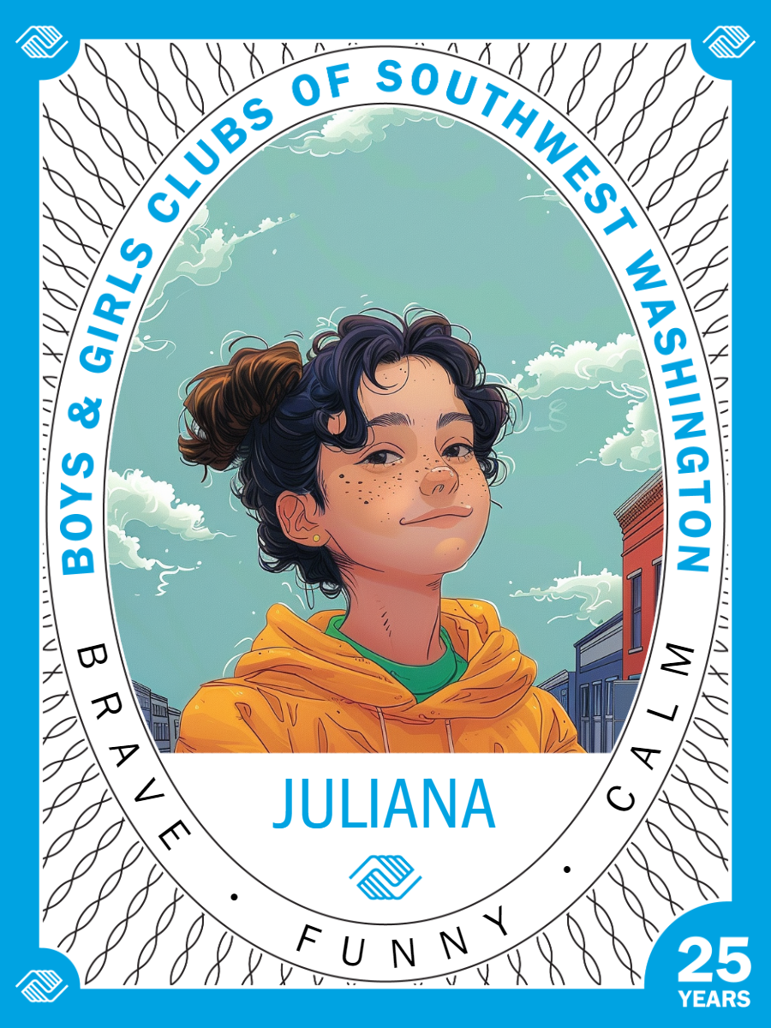

"We are thrilled to introduce the AI Photo Booth as part of our 25th-anniversary celebrations," said Nicole Aliotti, Director of Development & Communications at the Boys & Girls Clubs of Southwest Washington. "This innovative addition not only adds a unique element of fun to our events but also aligns perfectly with our commitment to embracing technology to enrich the lives of the youth we serve."
Join us in celebrating this milestone anniversary and creating a one of a kind experience for our community with the Empowered Together Photo Booth. For more information or to book the photo booth at your business or event please contact Nicole Aliotti,
nicolea@mybgc.org.

About Boys & Girls Clubs of Southwest Washington:
Founded in 1999, the Boys & Girls Clubs of Southwest Washington is a nonprofit organization dedicated to providing a safe and positive environment for youth development. With multiple Club locations and a wide range of programs, BGCSW empowers young people to reach their full potential as productive, caring, and responsible community members.

For Media Inquiries:
Nicole Aliotti
Director of Development & Communications
Email: Nicolea@mybgc.org
Phone: (360)787-2067

